

**Foundation in Computing**

**ITS30305 Web Programming**

**Assignment 1**

**(Individual Assignment)**

**Hand out Date: 24th October 2017 (Tuesday)**

**Hand in Date: 8th November 2017 (Wednesday)**

**Presentation time: 7th/8th November 2017 (During class time)**

**Weightage: 15%**

**Instructions to students:**

* The assignment should be attempted individually
* Complete this cover sheet and attach it to your assignment – this should be your first page!

|  |  |
| --- | --- |
| **Student declaration:** | |
| ***I declare that:***   1. ***I understand what is meant by plagiarism*** 2. ***The implication of plagiarism have been explained to us by our lecturer***   ***This project is all our work and I have acknowledged any use of the published or unpublished works of other people.*** | |
| **Name (Student ID)** | **Signature** |
| **Yeo Kai Nee (0331435)** |  |

*Avoid copy and paste job in your report and it is considered as plagiarism. Plagiarism in all forms is forbidden. Students who submit plagiarised assignment will deserved a 0 marks.*

TABLE OF CONTENTS

Introduction 1

Purpose of the Website 1

Target Audience 1

Website design 2

Site Map 2

Story Board 3

Appendix 4

Screen Captures #

Source Code #

References #

List of Referencing #

**INTRODUCTION**

I had made a website, named Myle.lifehack, which means “Make your life easier Life Hack”. Basically, this is a website that provides you various, unique, and useful life hacks. Life Hack is a tool or technique that makes some aspect of one's life easier or more efficient. It is also a term the technologically (mostly) illiterate throw around to demonstrate that they understand these new-fangled computers. Formerly known as "good ideas." So, Myle Life Hack provides you all the life hack method to ease your daily activities.

Purpose of this website

* Learn getting things done in the most favourable and trouble-free way
* More productivity and convenience
* Inspire you and make your life easier
* Increase Your Creativity and Innovation
* Makes living more interesting

Target Audience

Target audience for this website will be the community who are interested about life hack, as the post in this website are open and no age restrictions.

**WEBSITE DESIGN**

Site Map

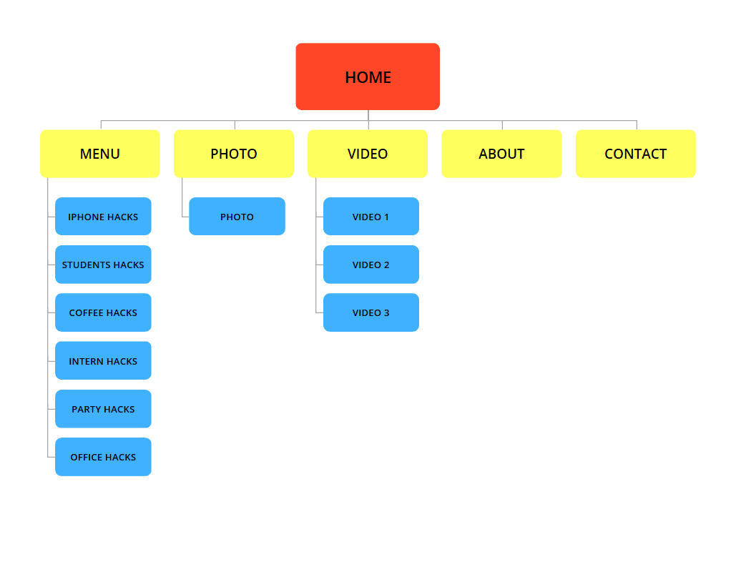

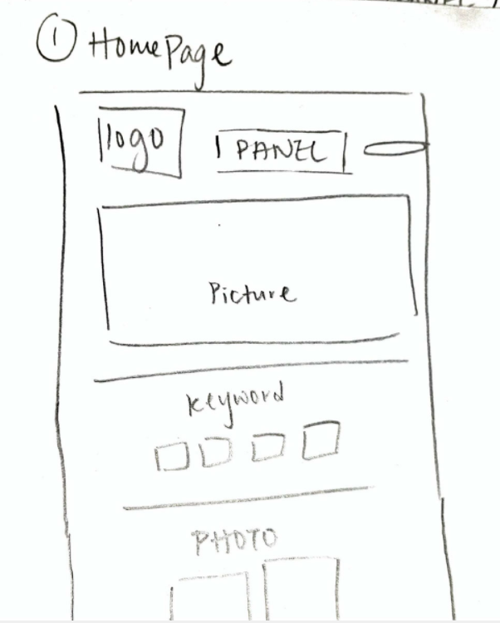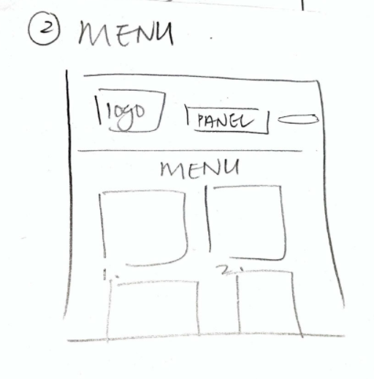Story Board

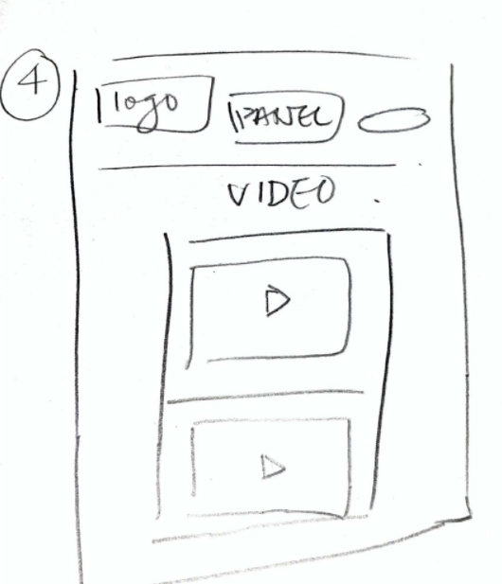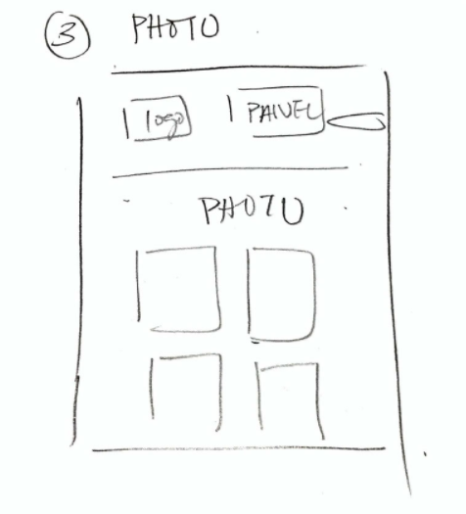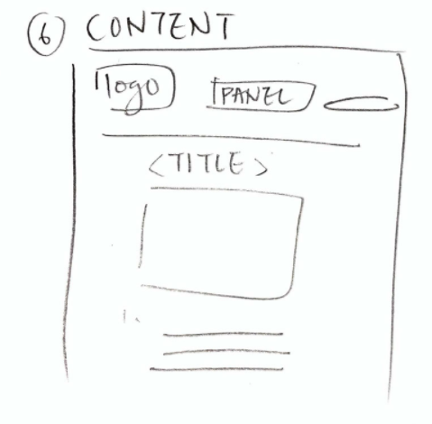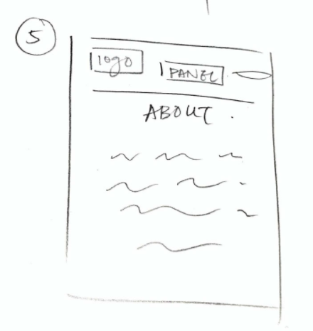

**APPENDIX**

Screen Capture

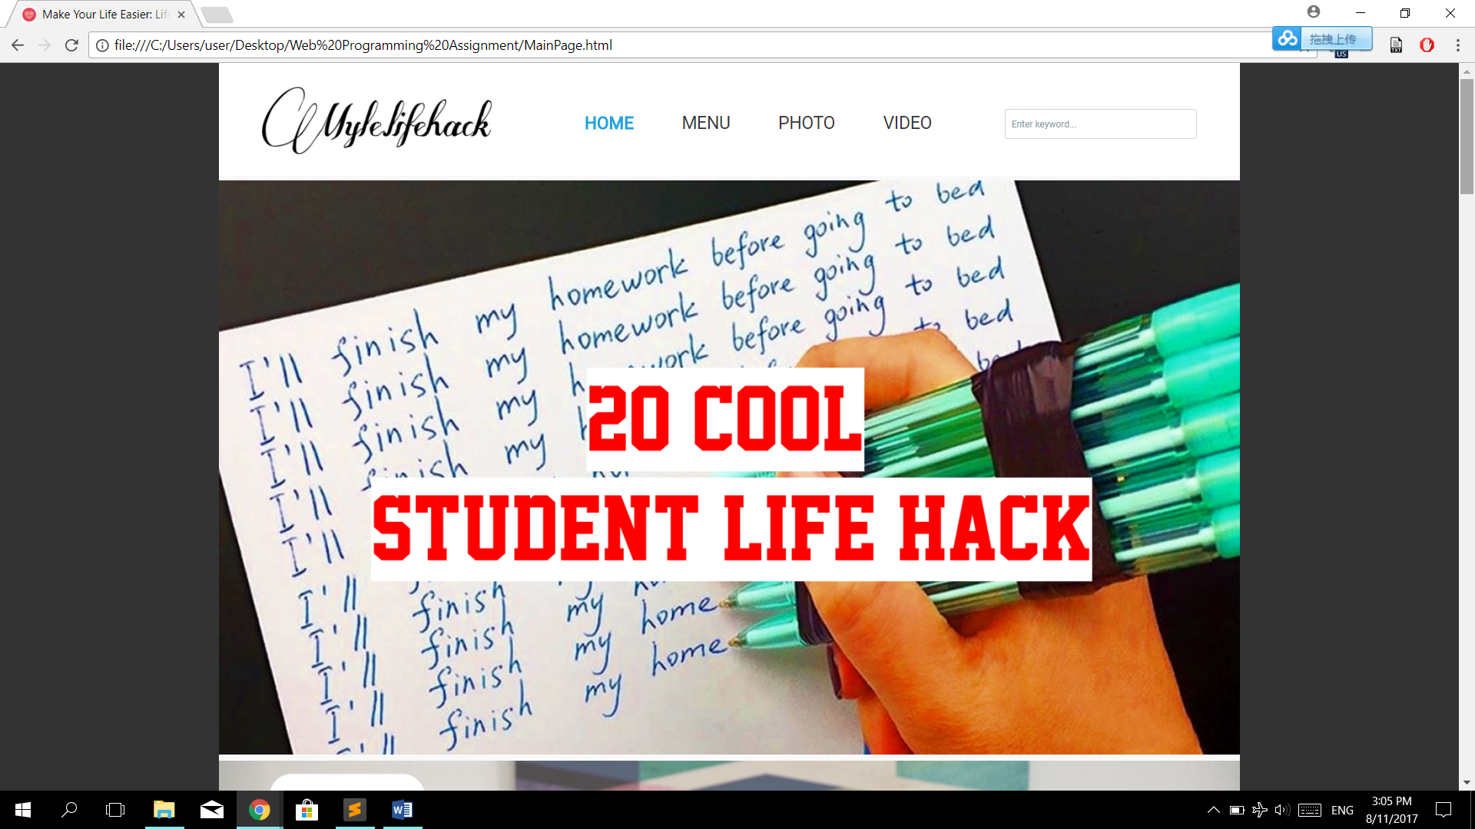

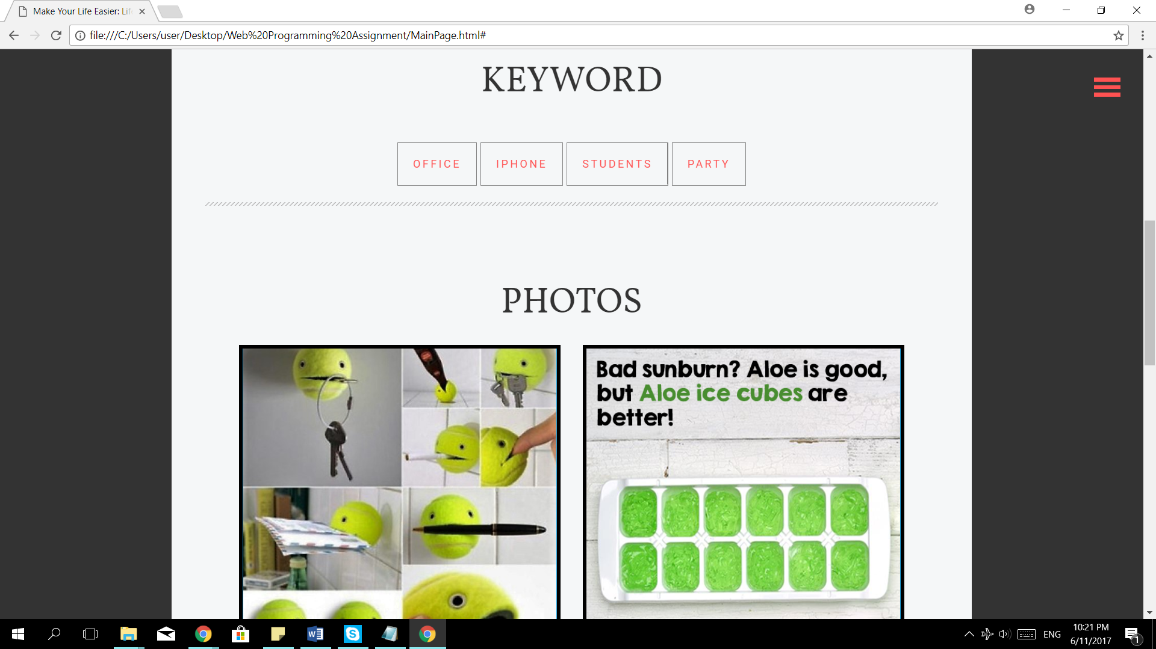

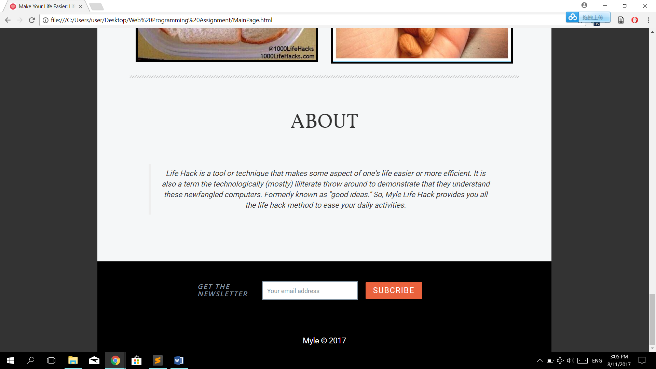

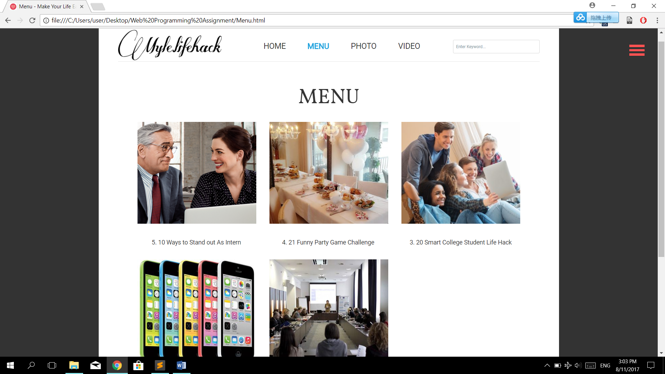

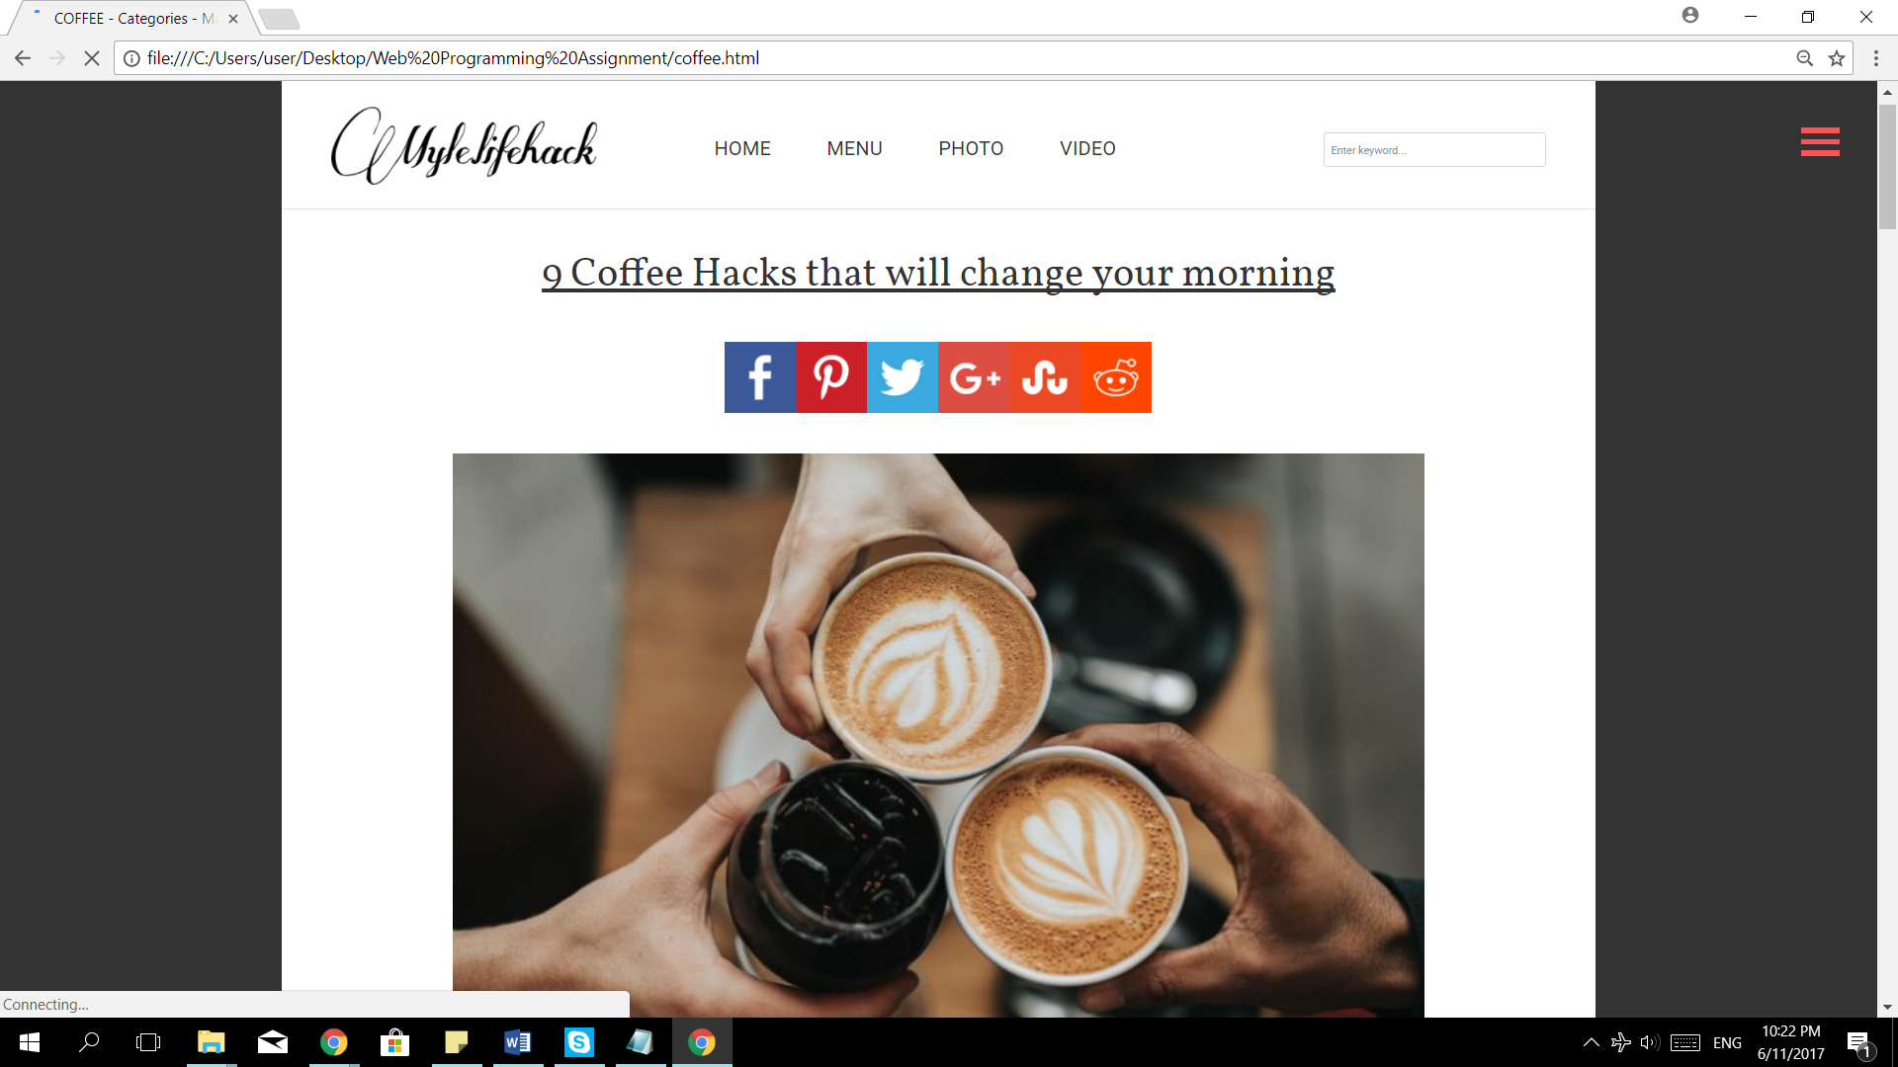

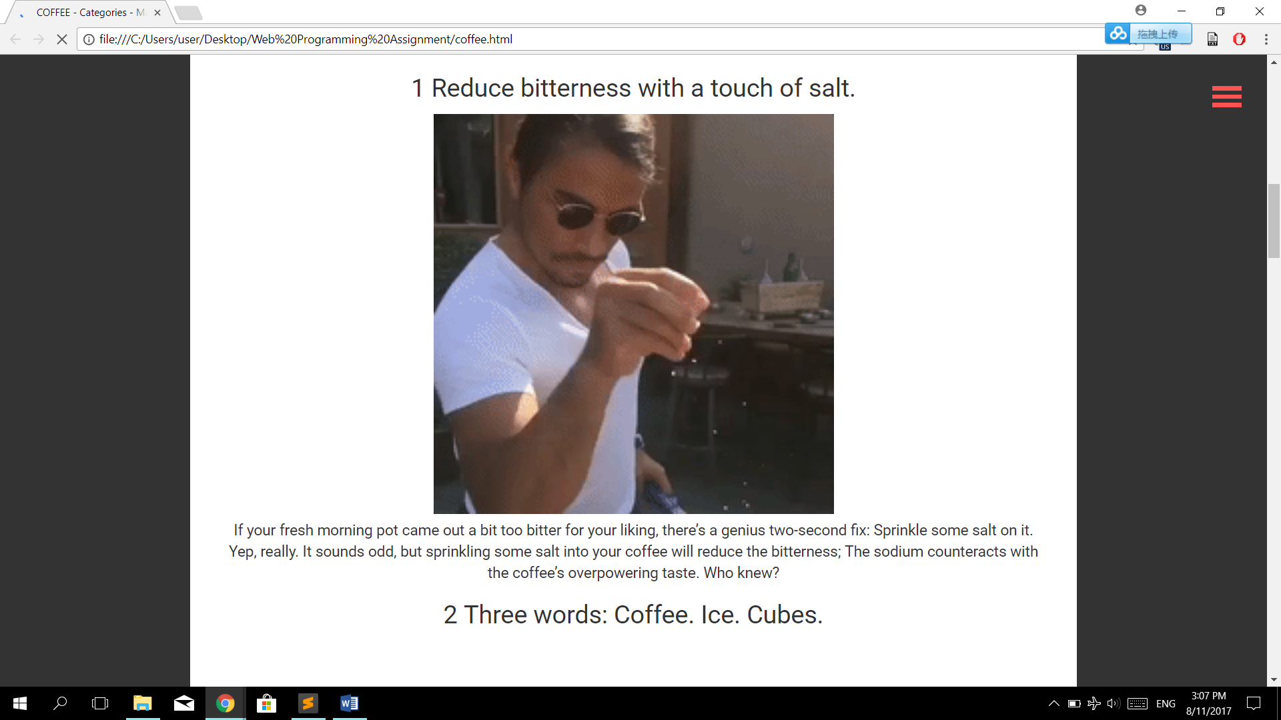

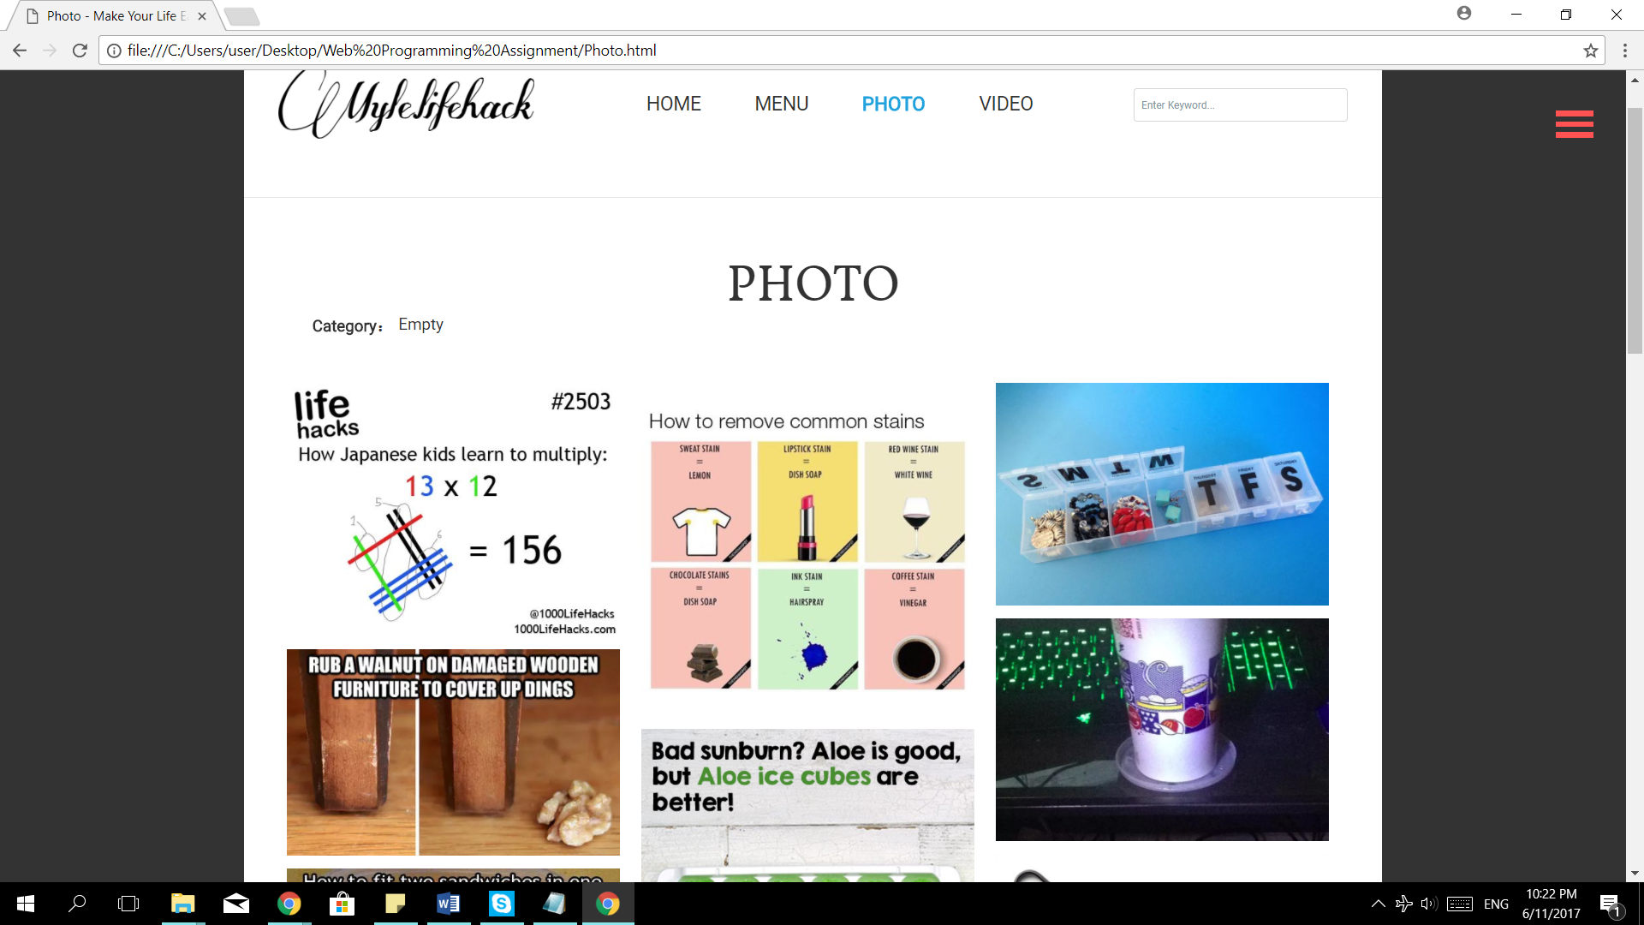

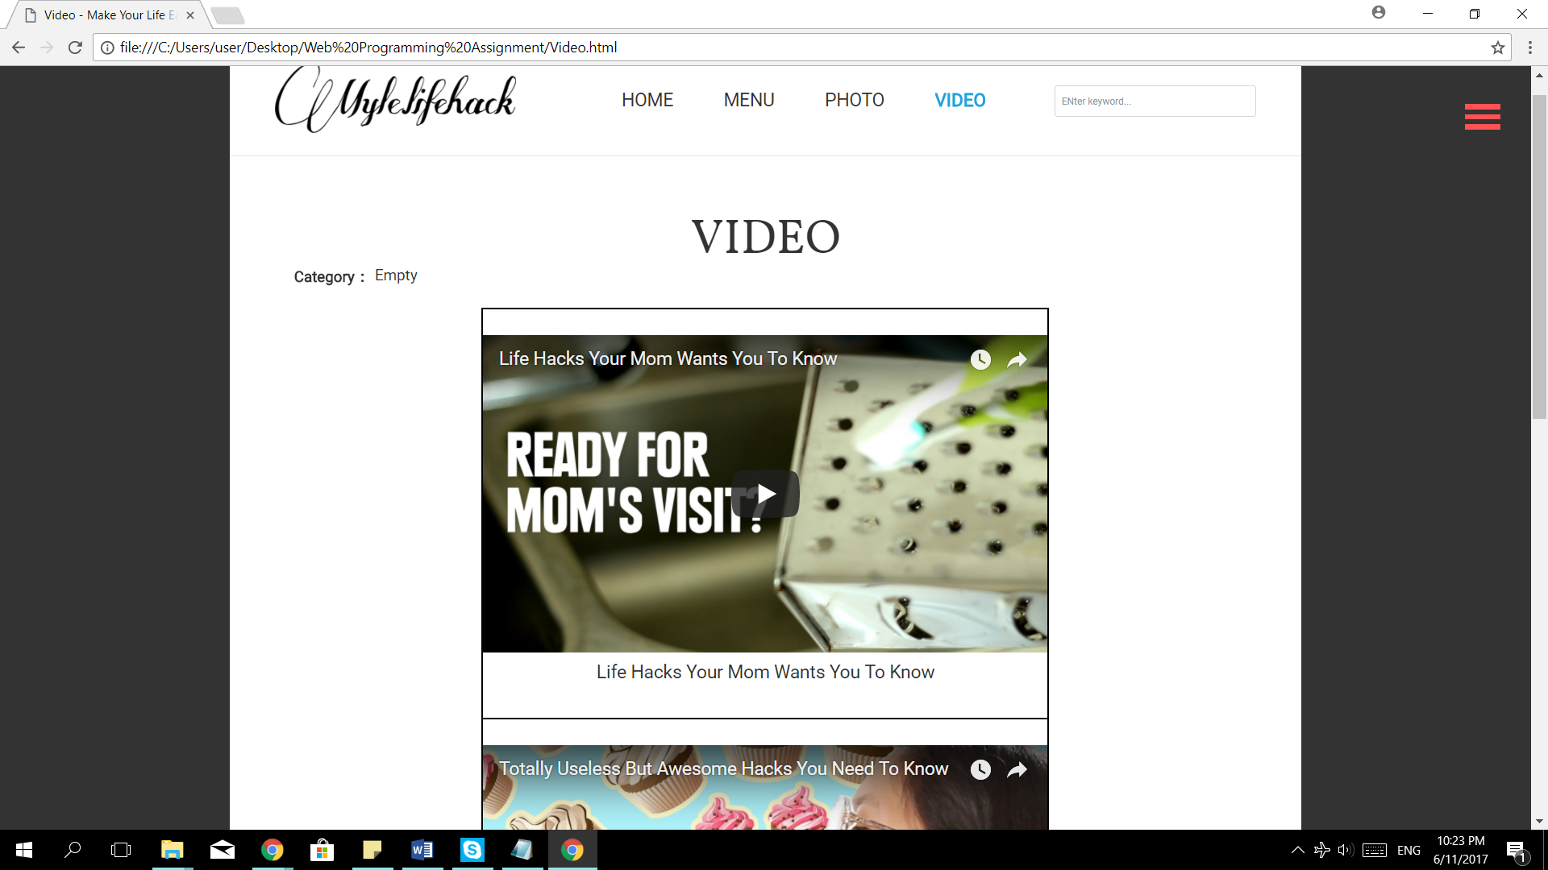

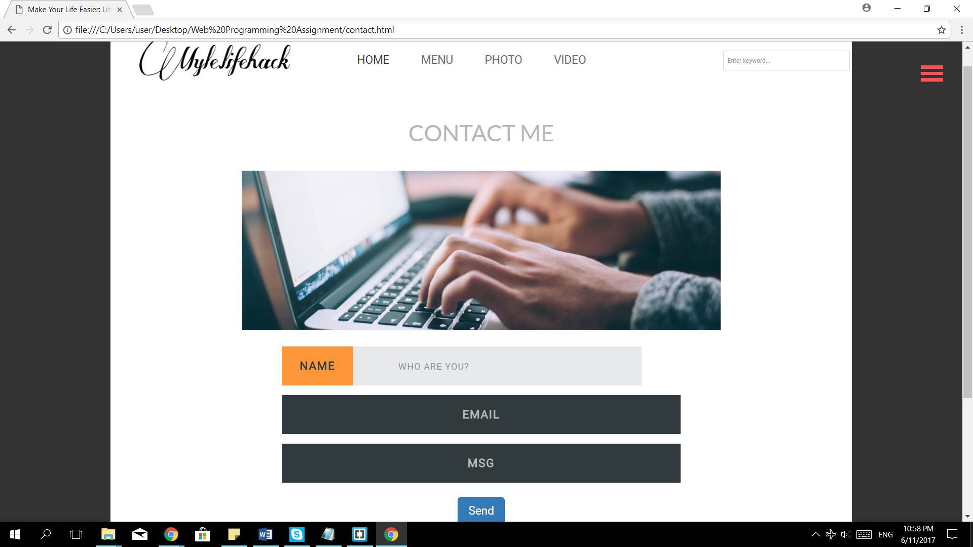

Source Code

(FULL SOURCE CODE: https://github.com/KaiNeemiiiiing/Wp1)

1. Main Page

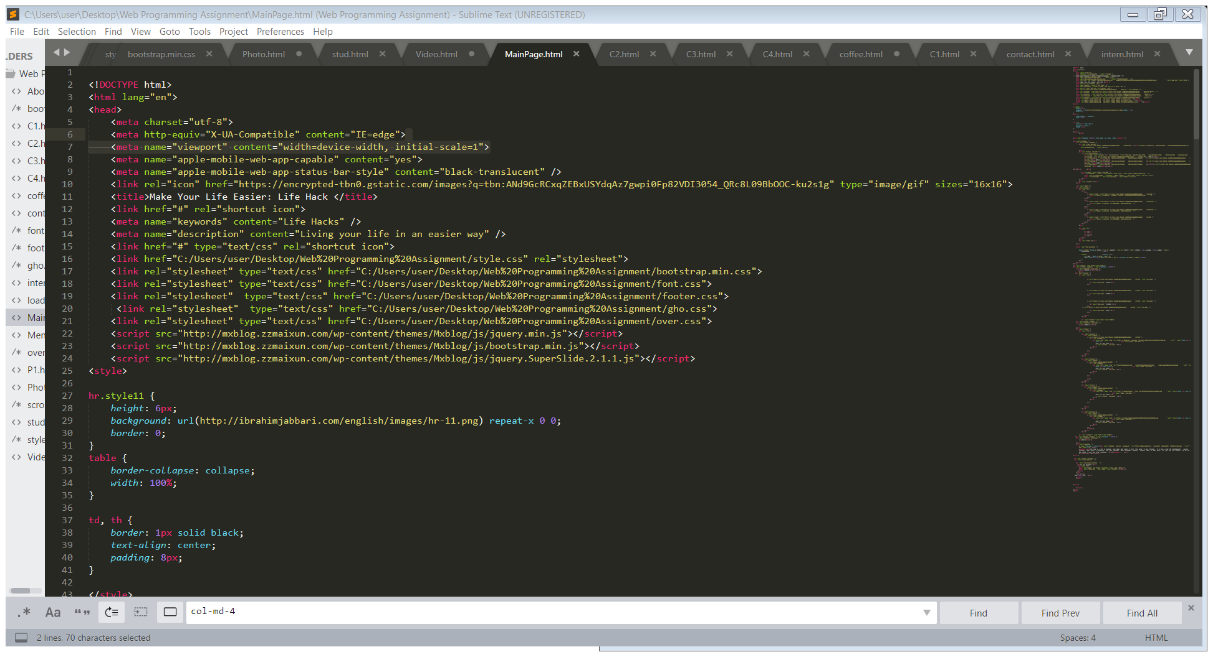

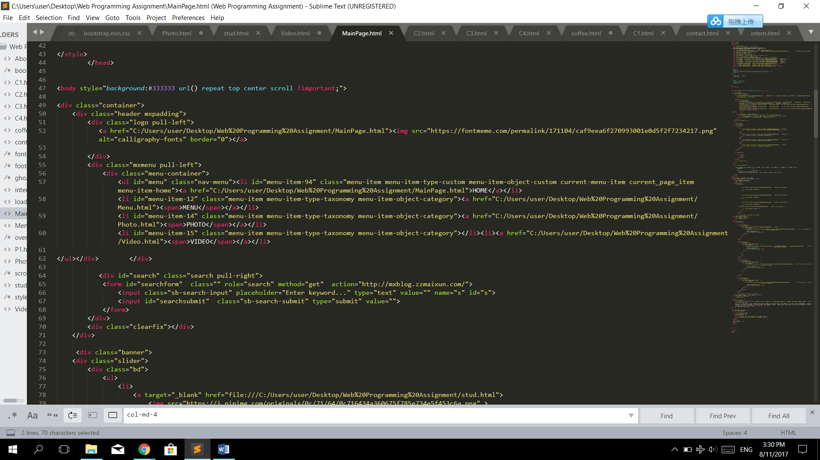

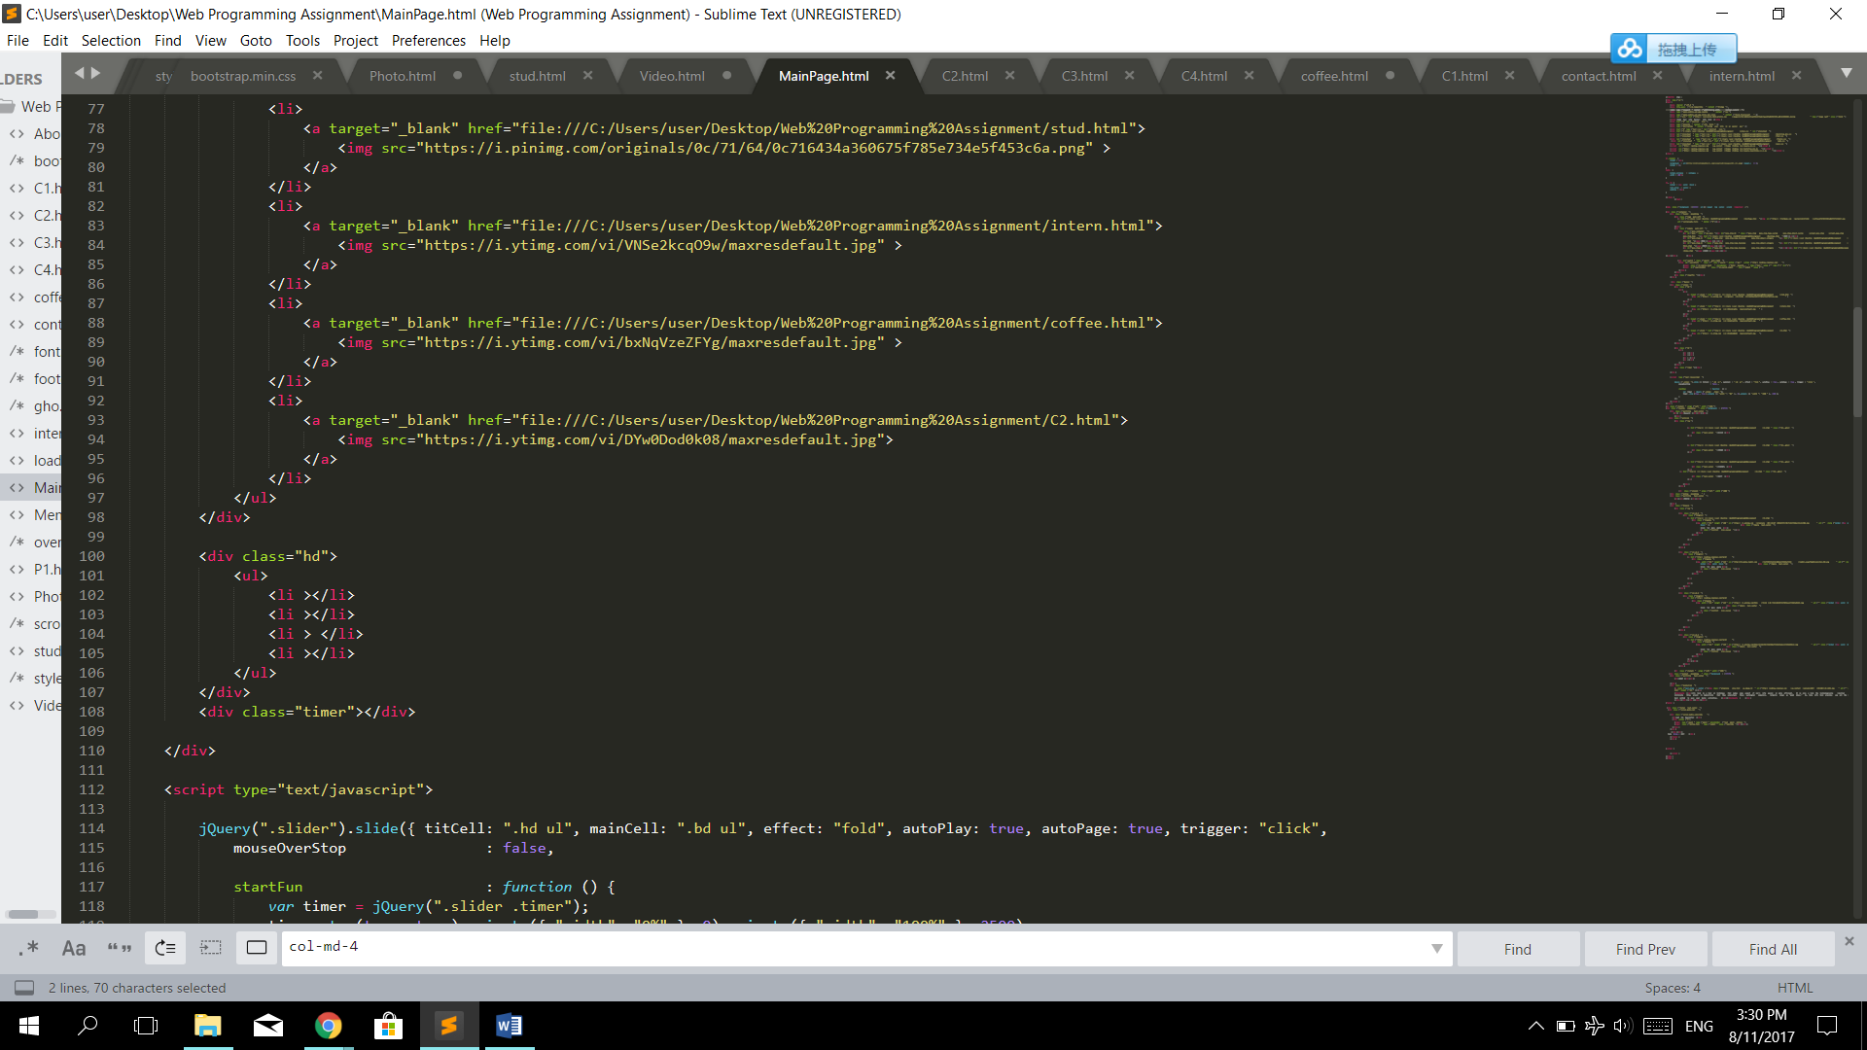

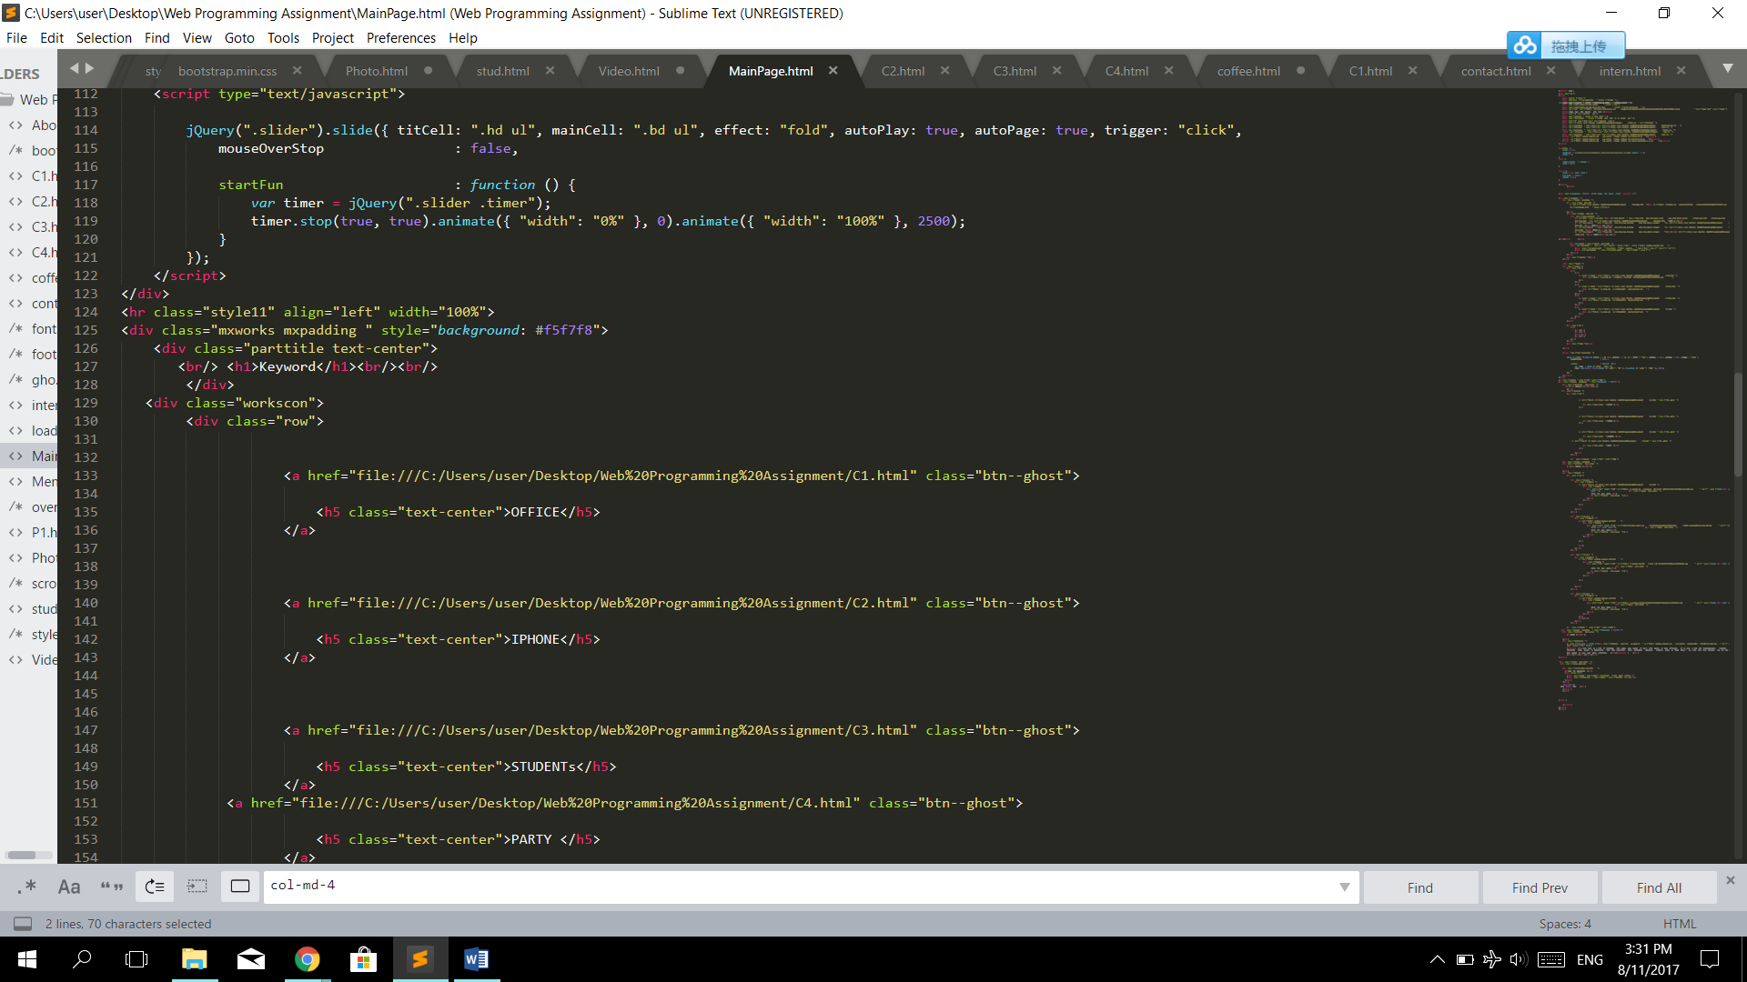

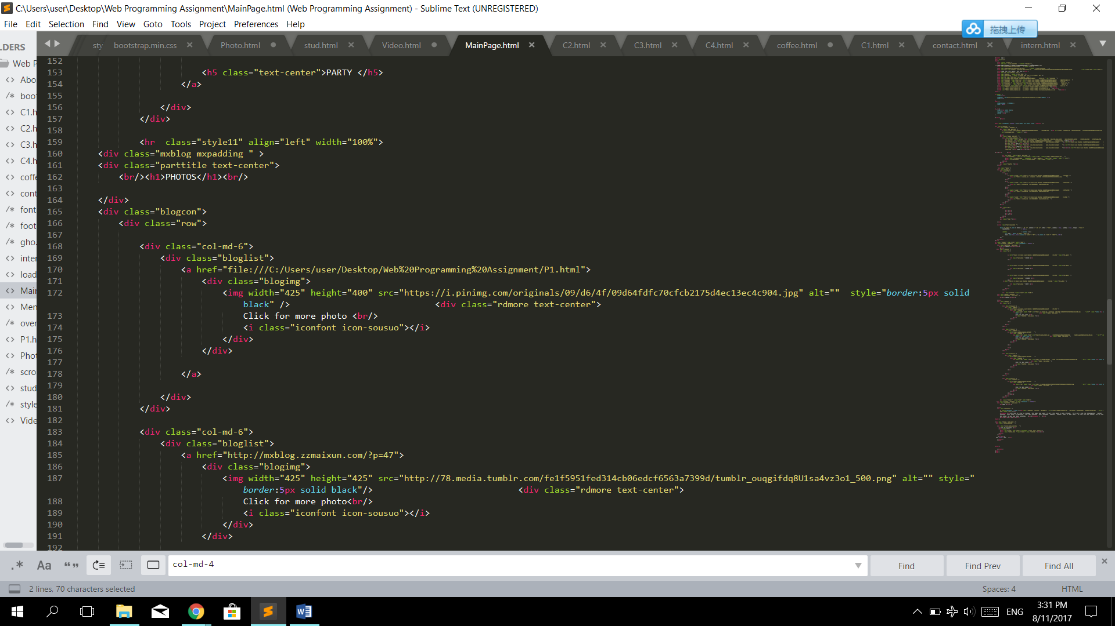

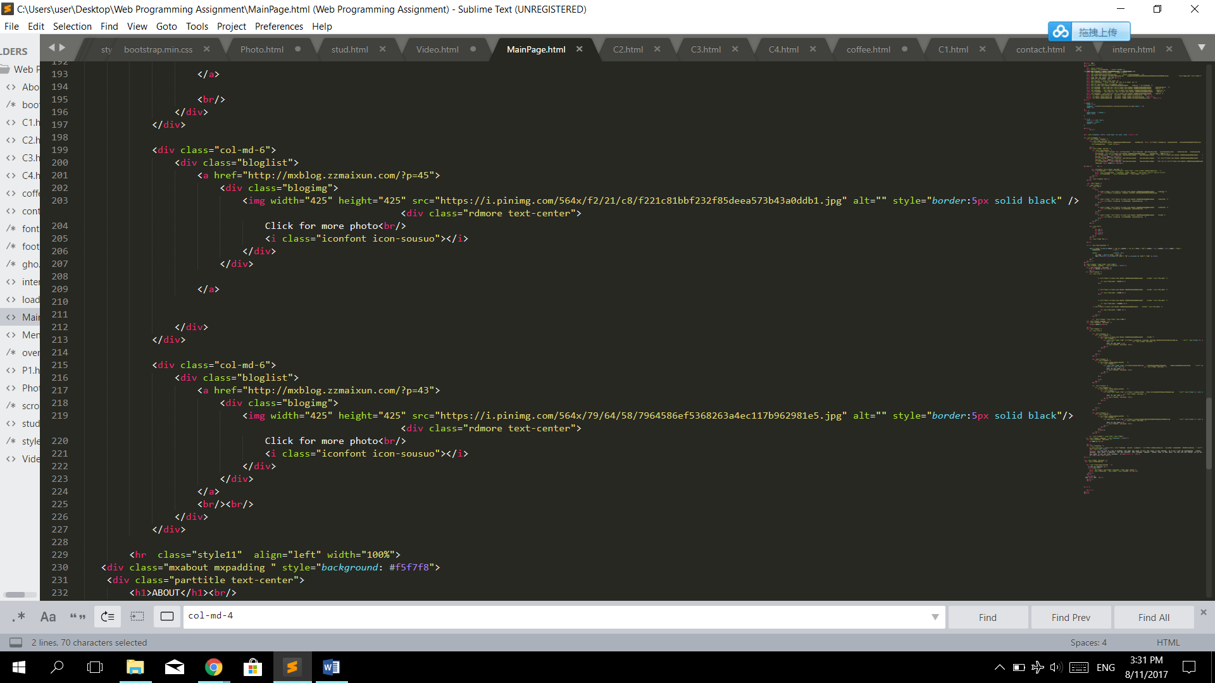

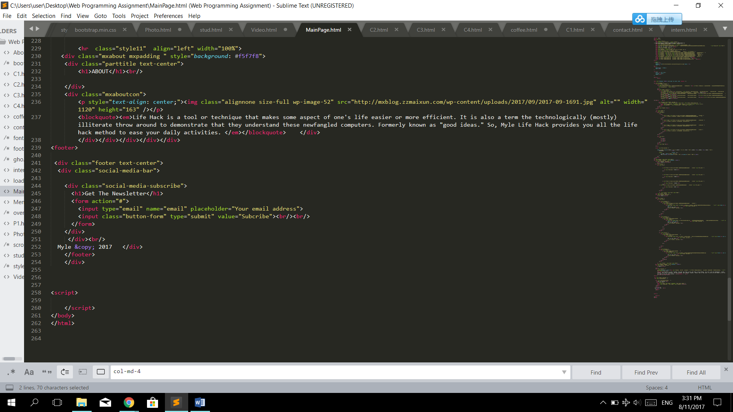

1. Menu

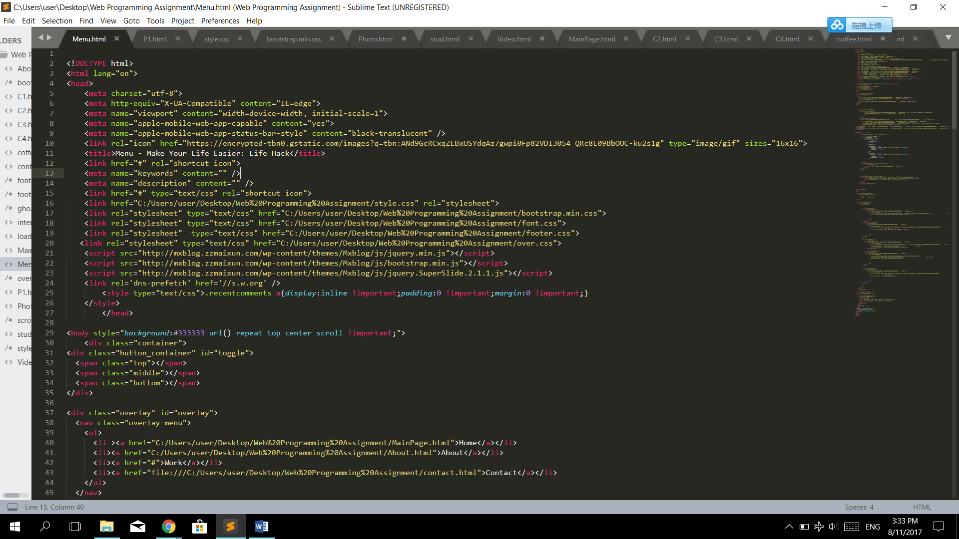

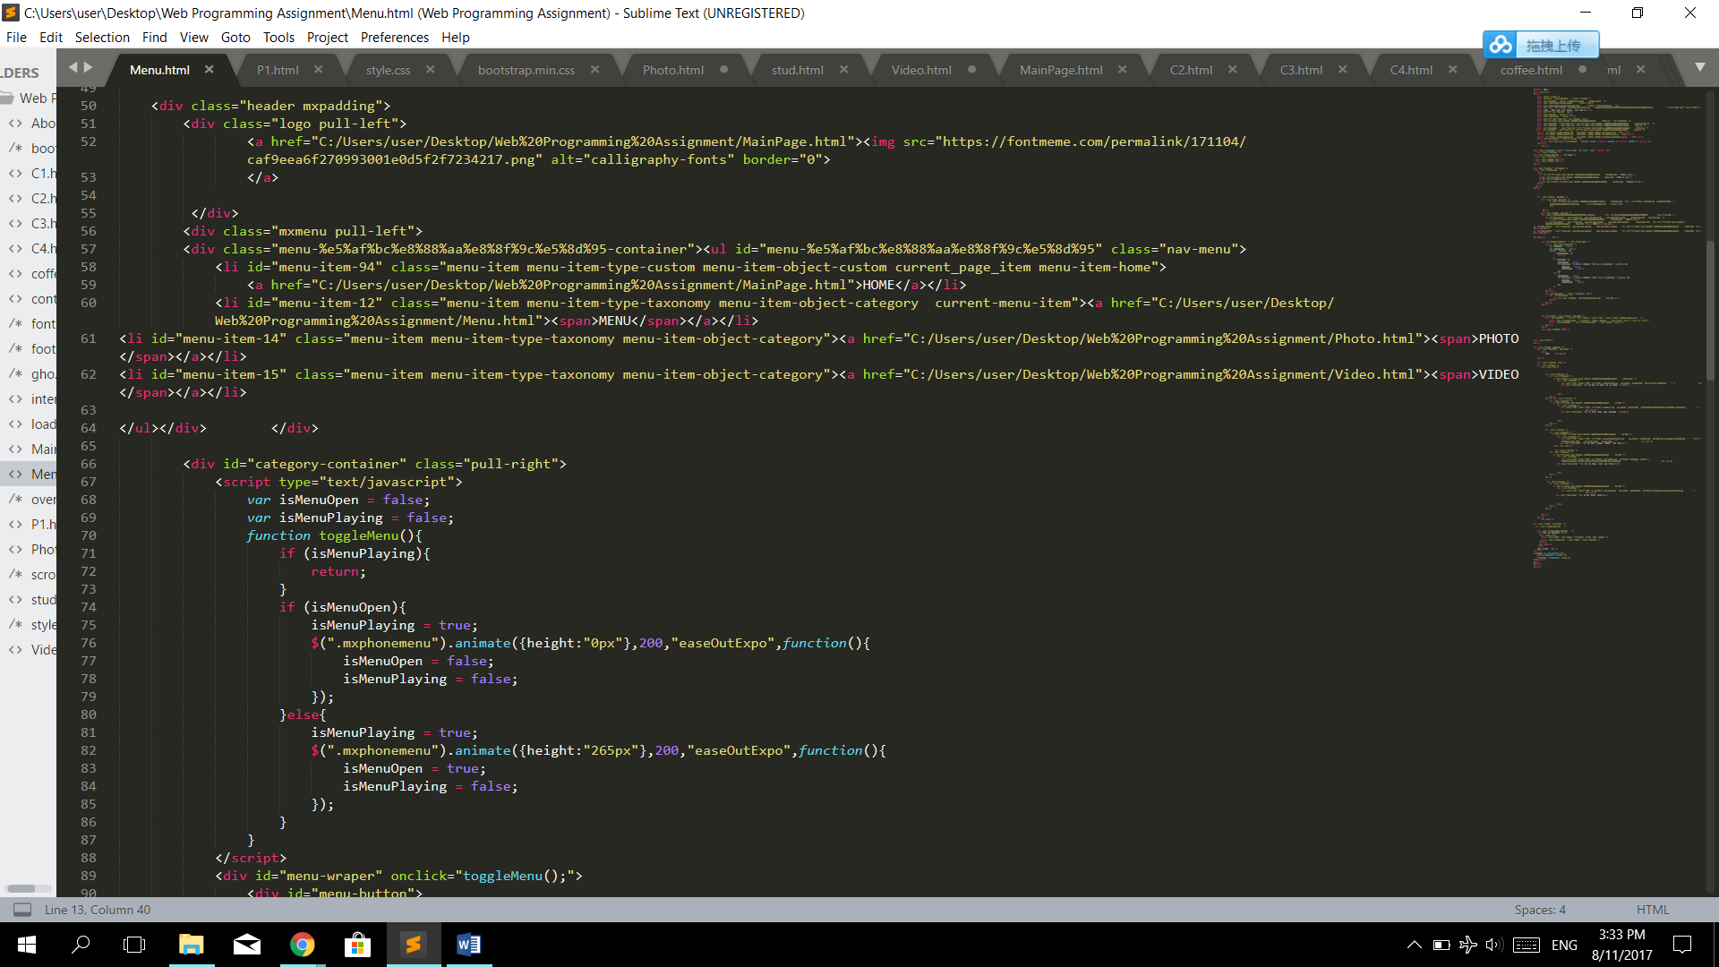

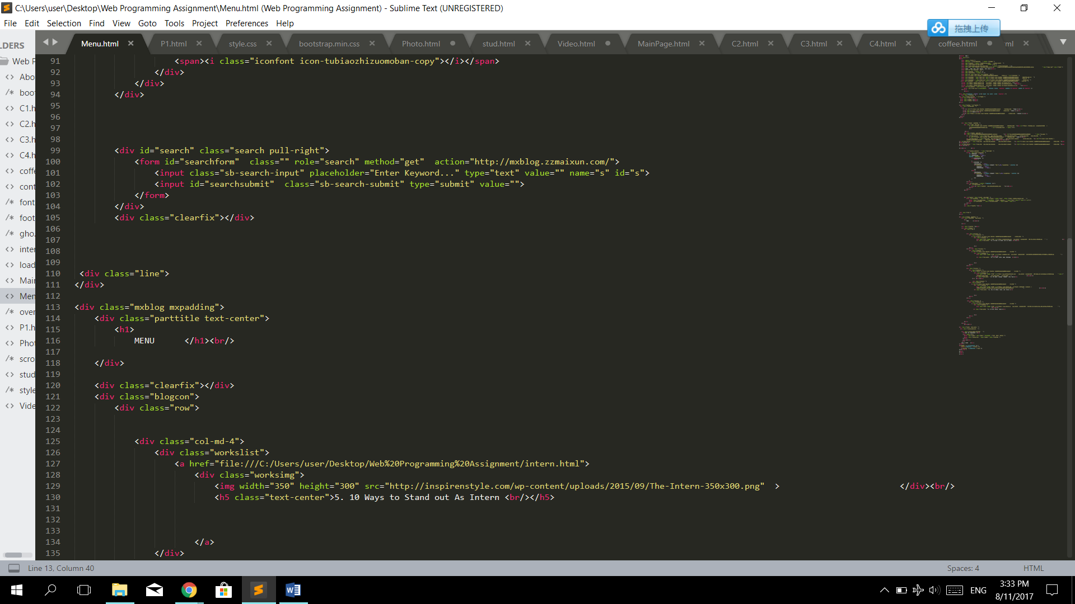

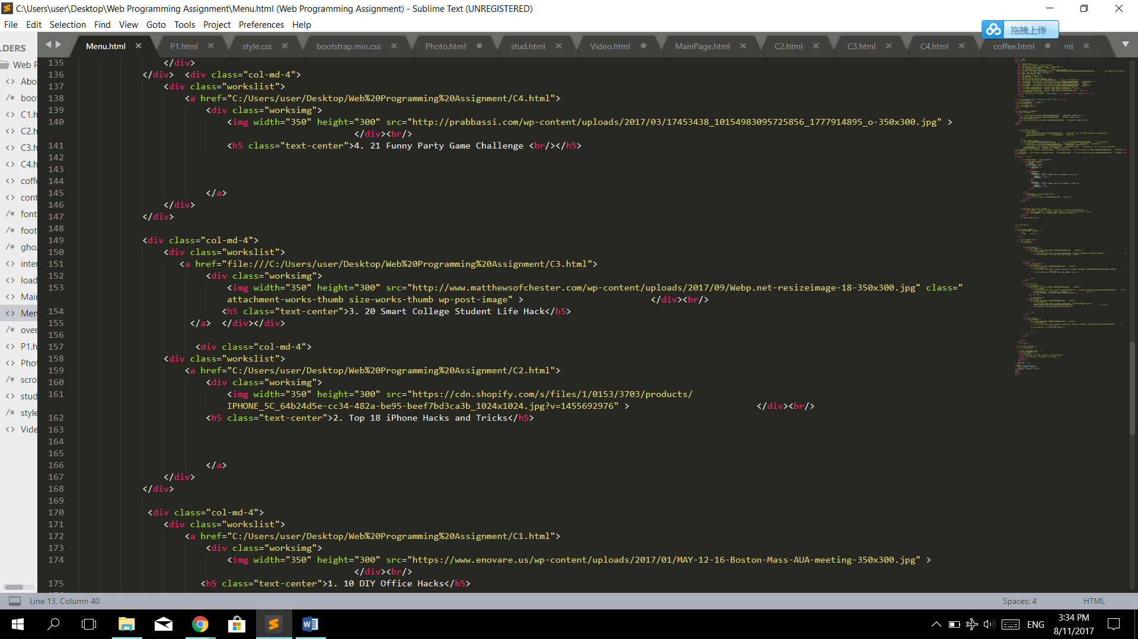

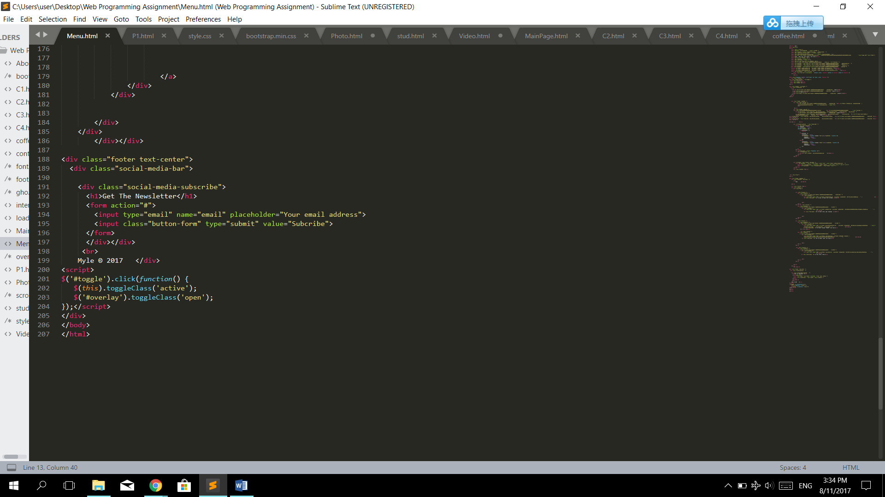

1. Photo

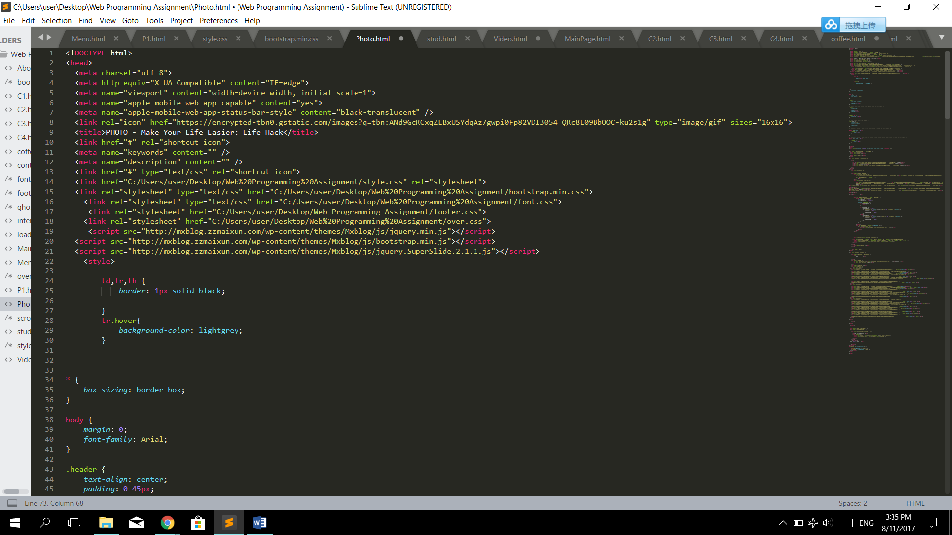

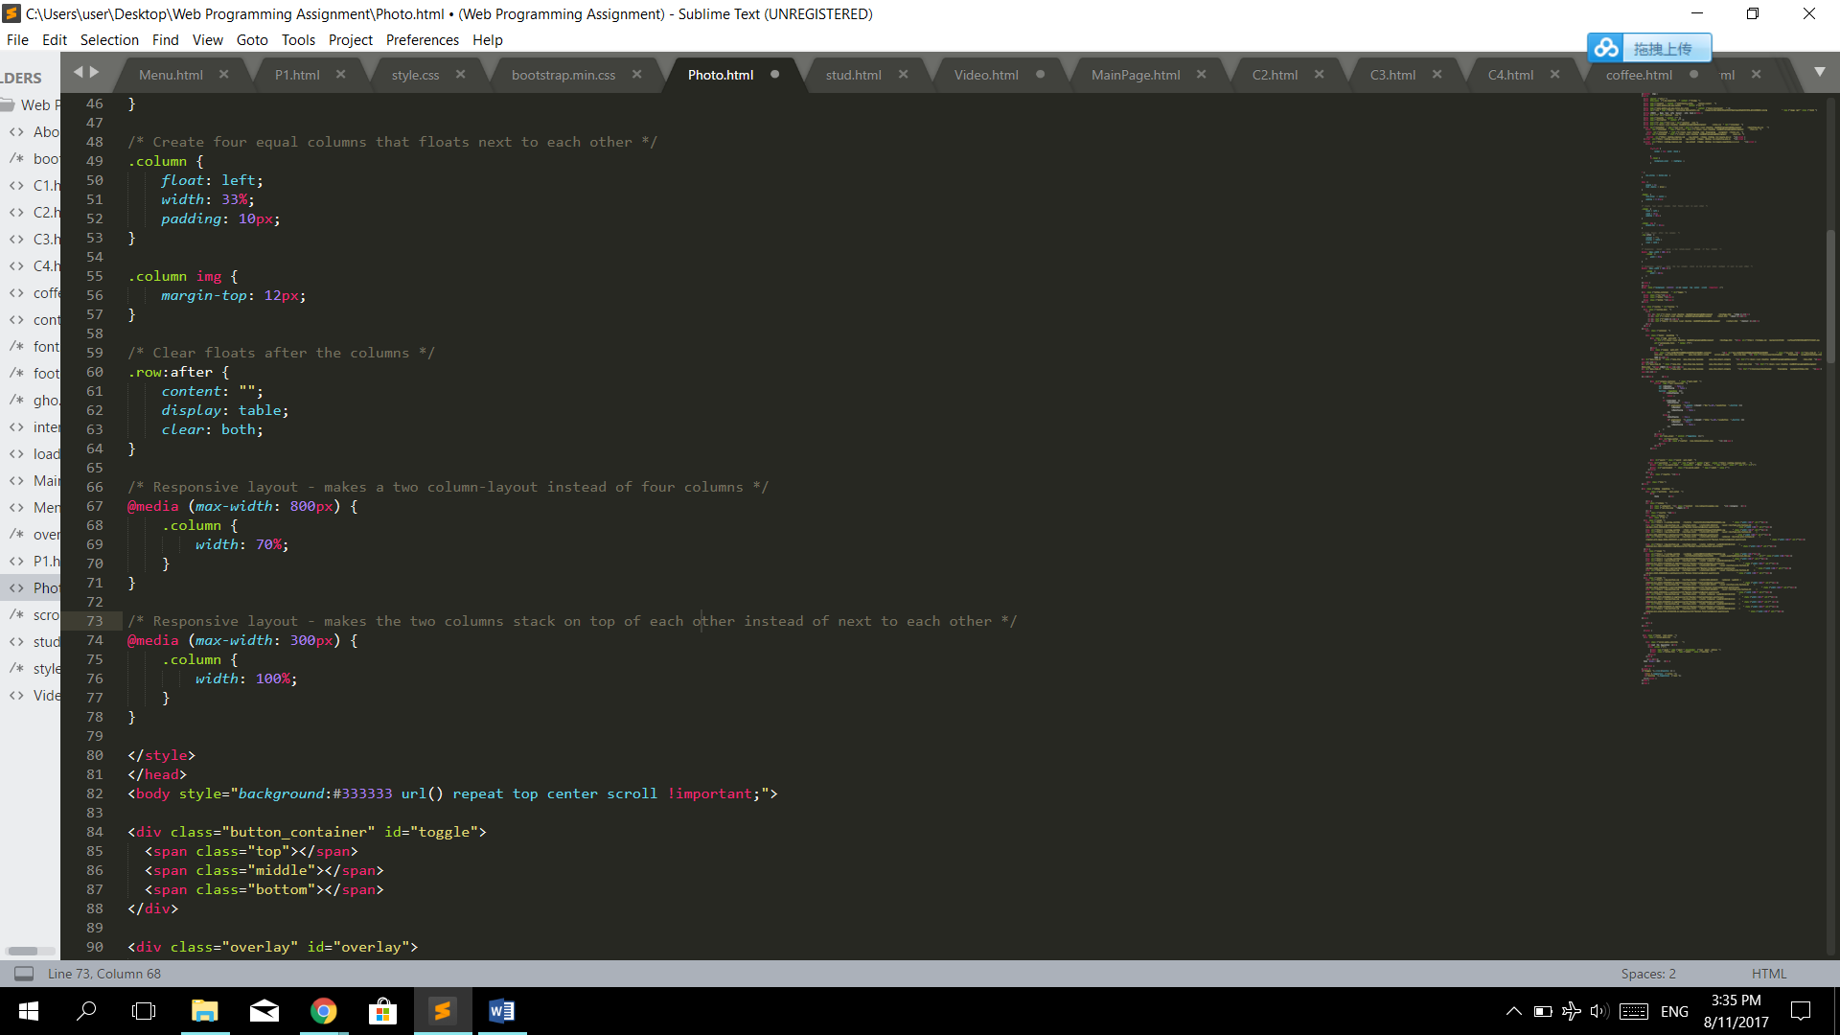

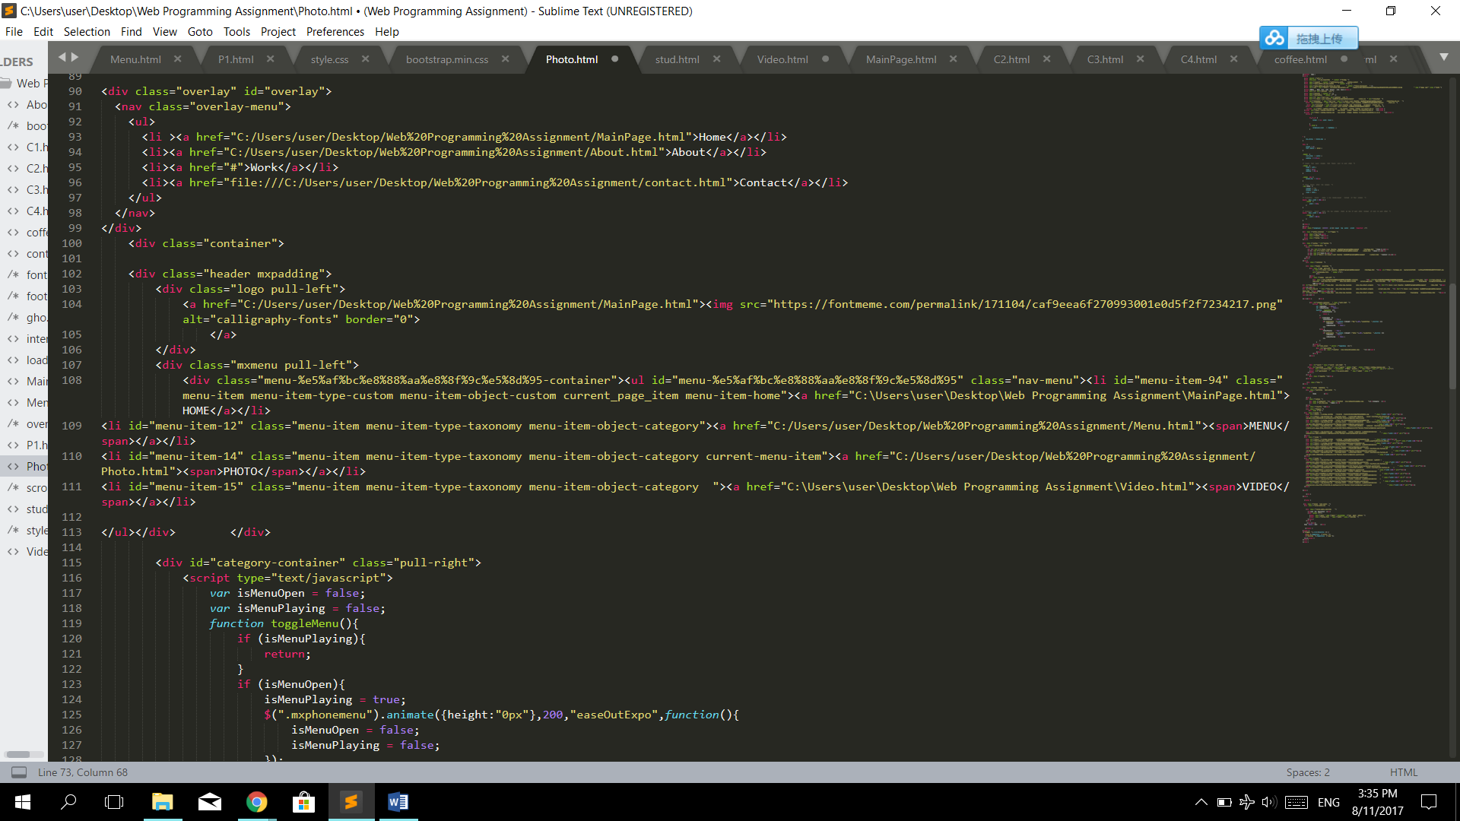

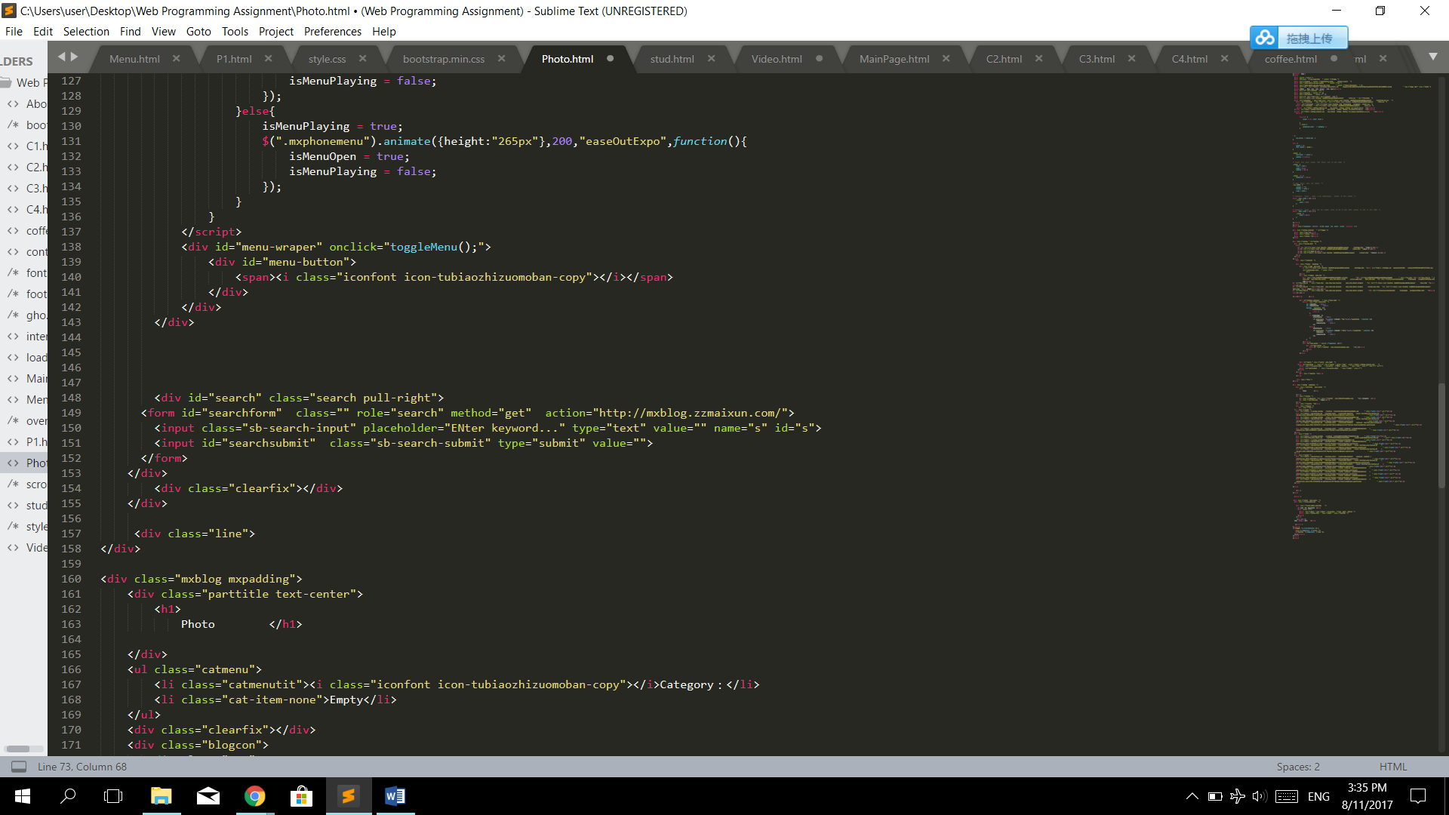

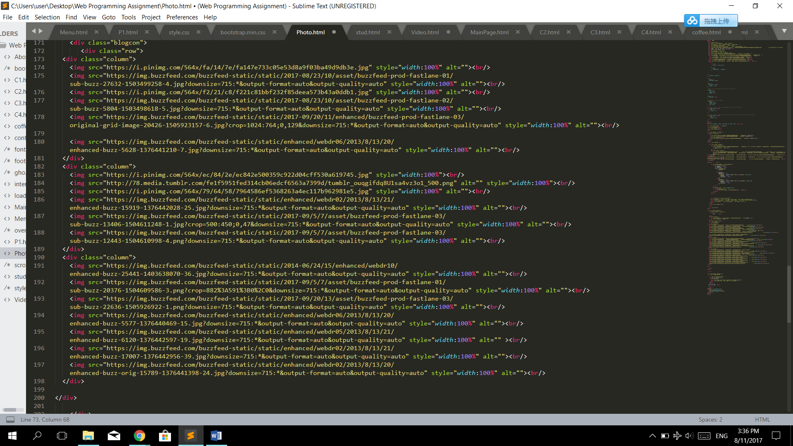

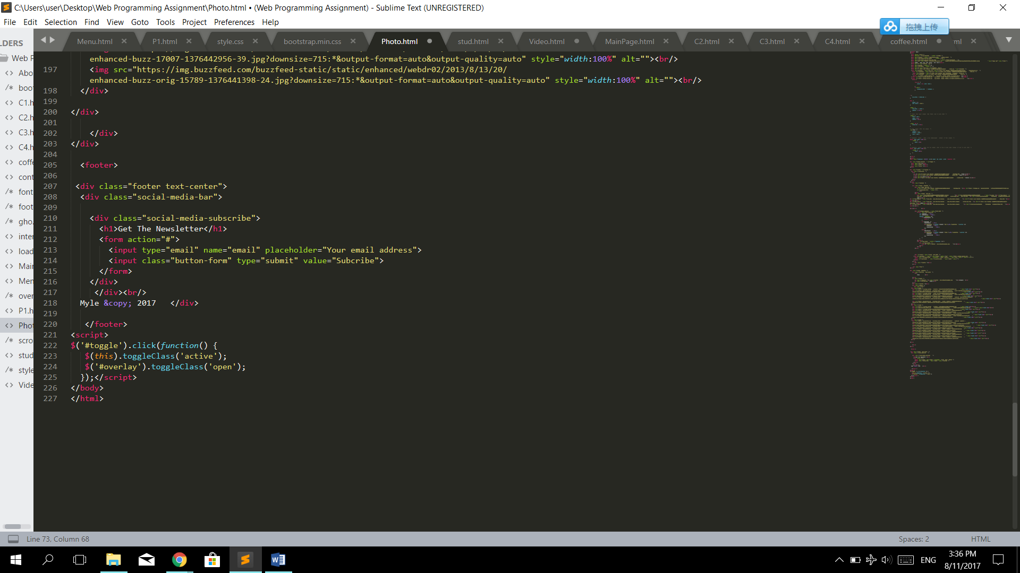

1. Video

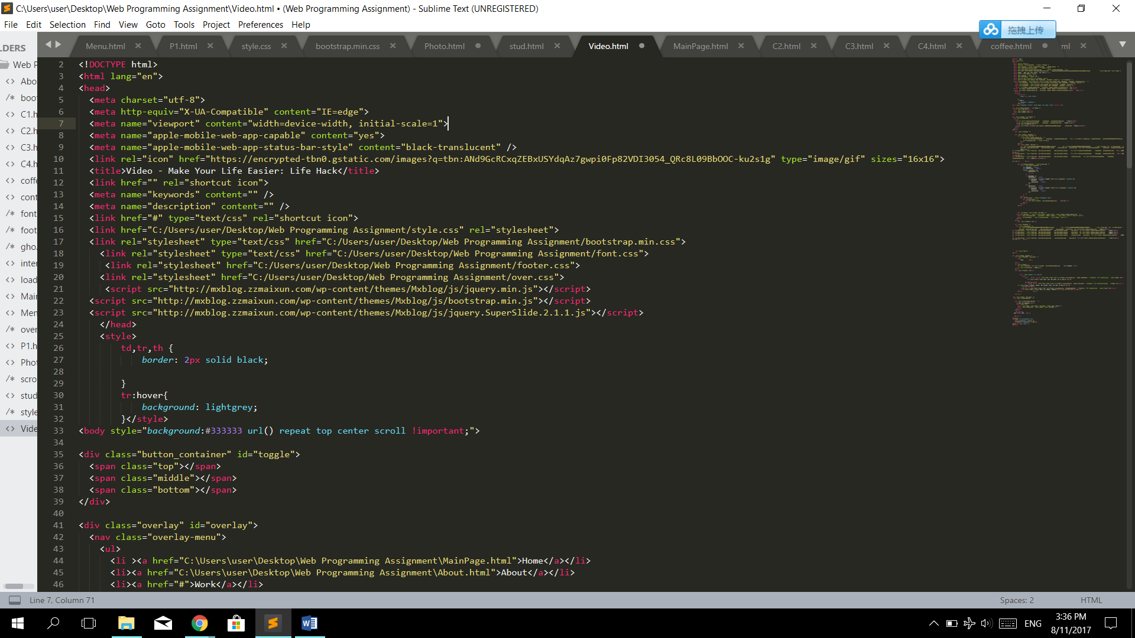

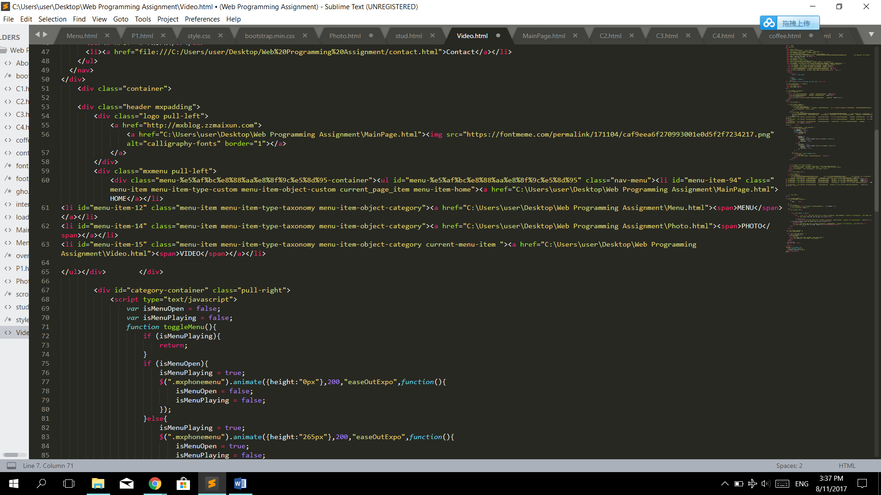

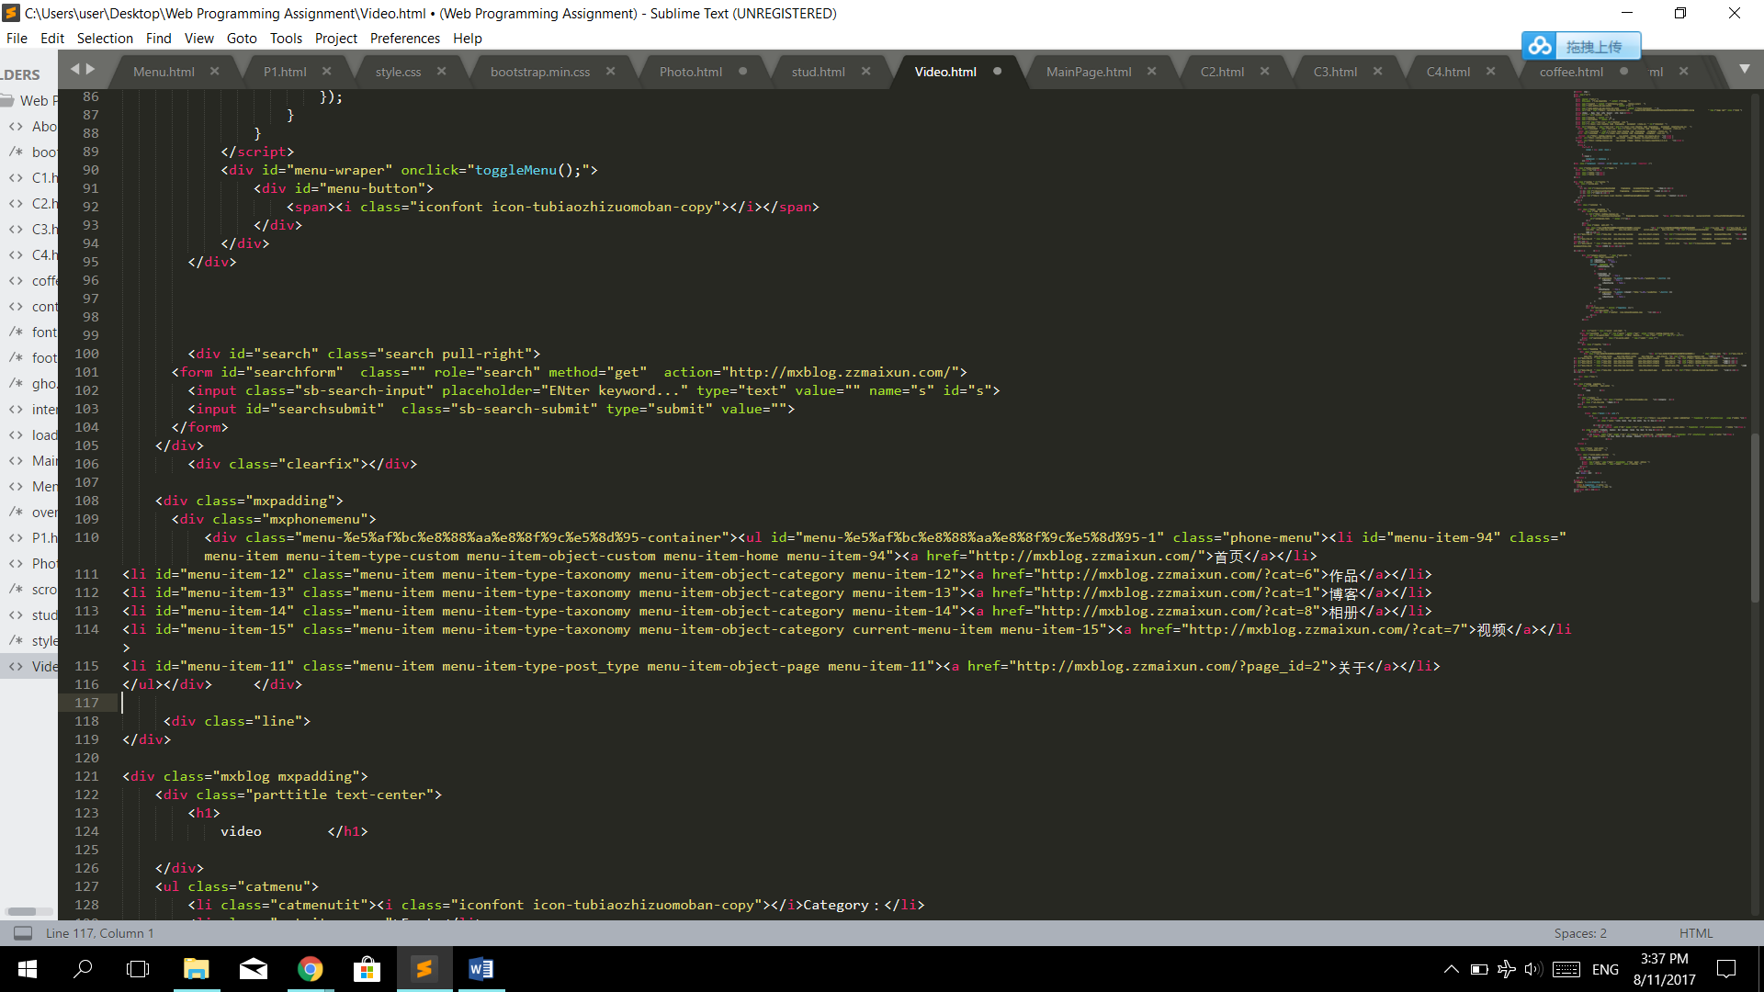

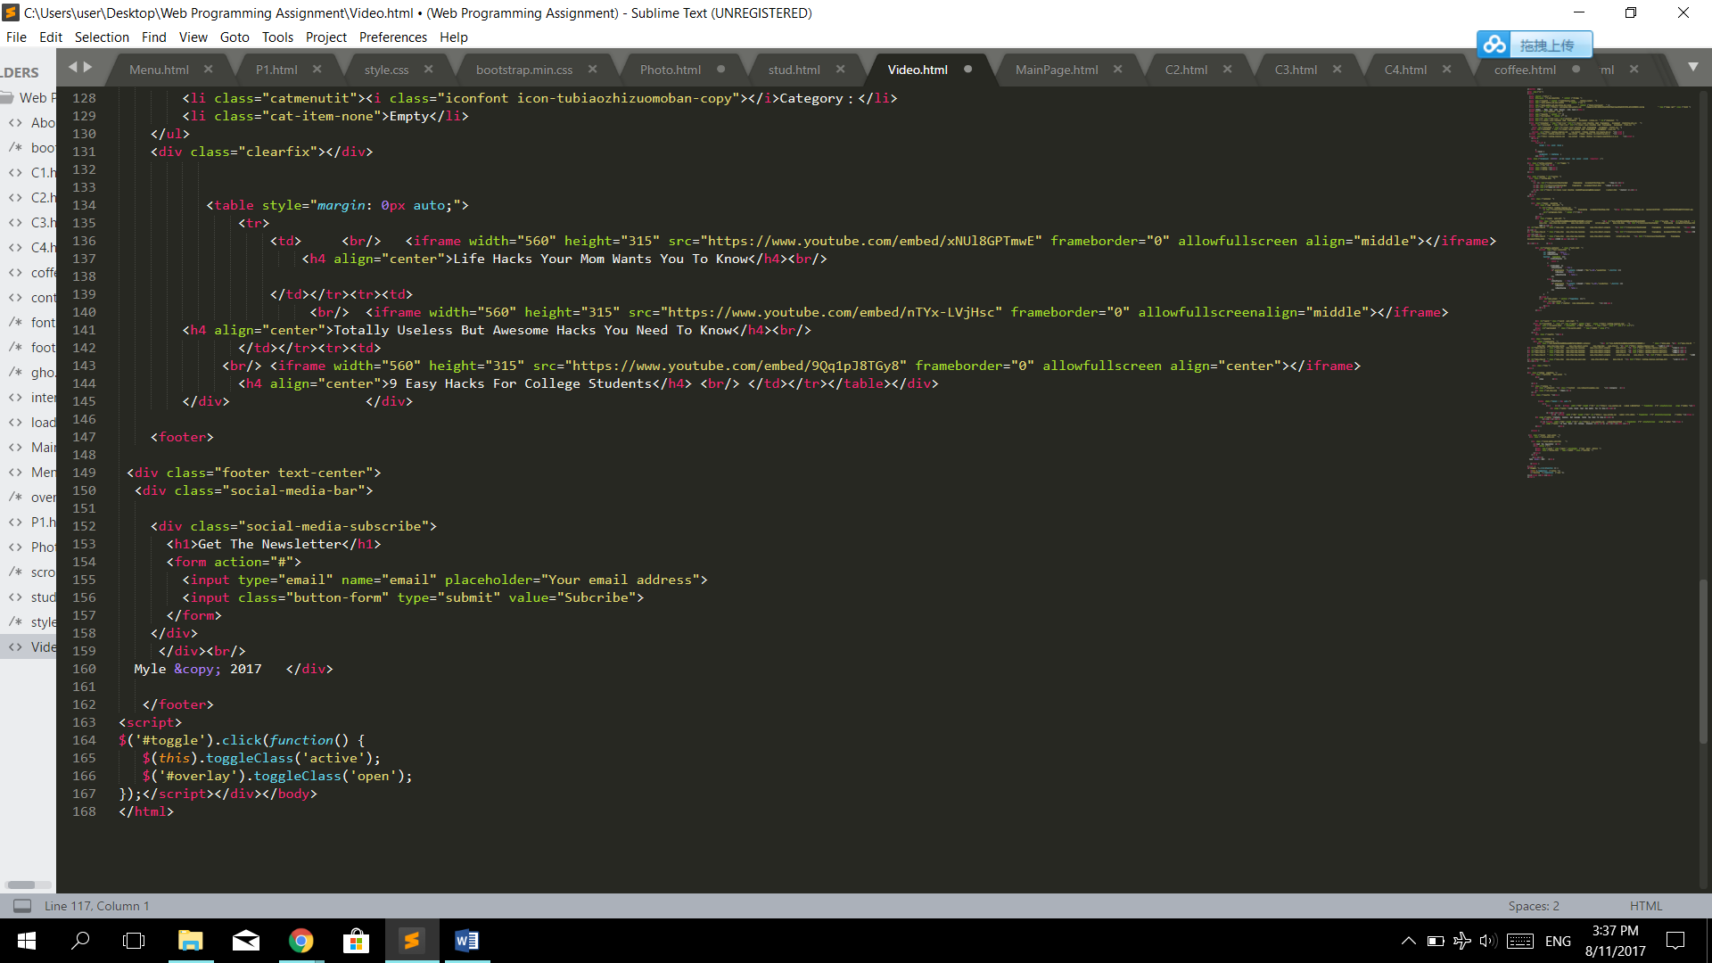

1. 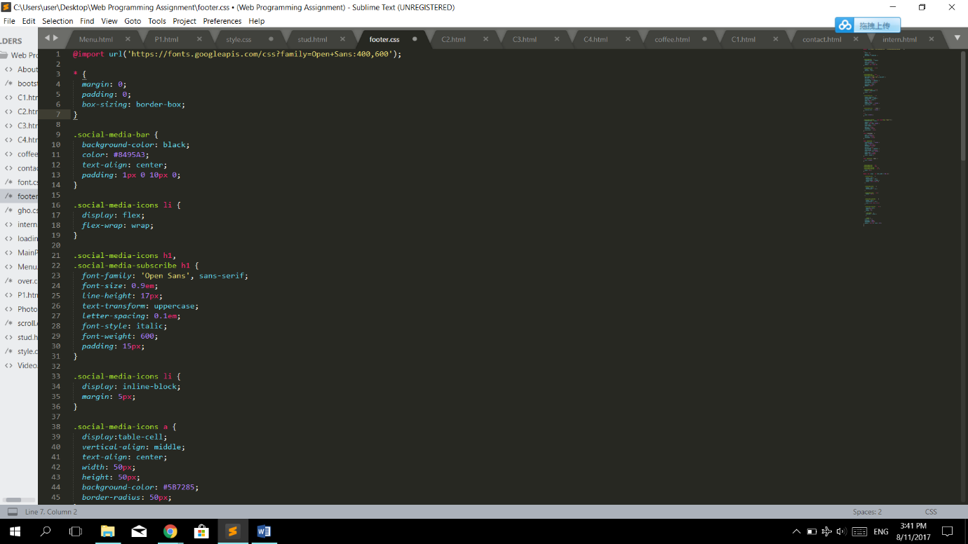Footer (Css)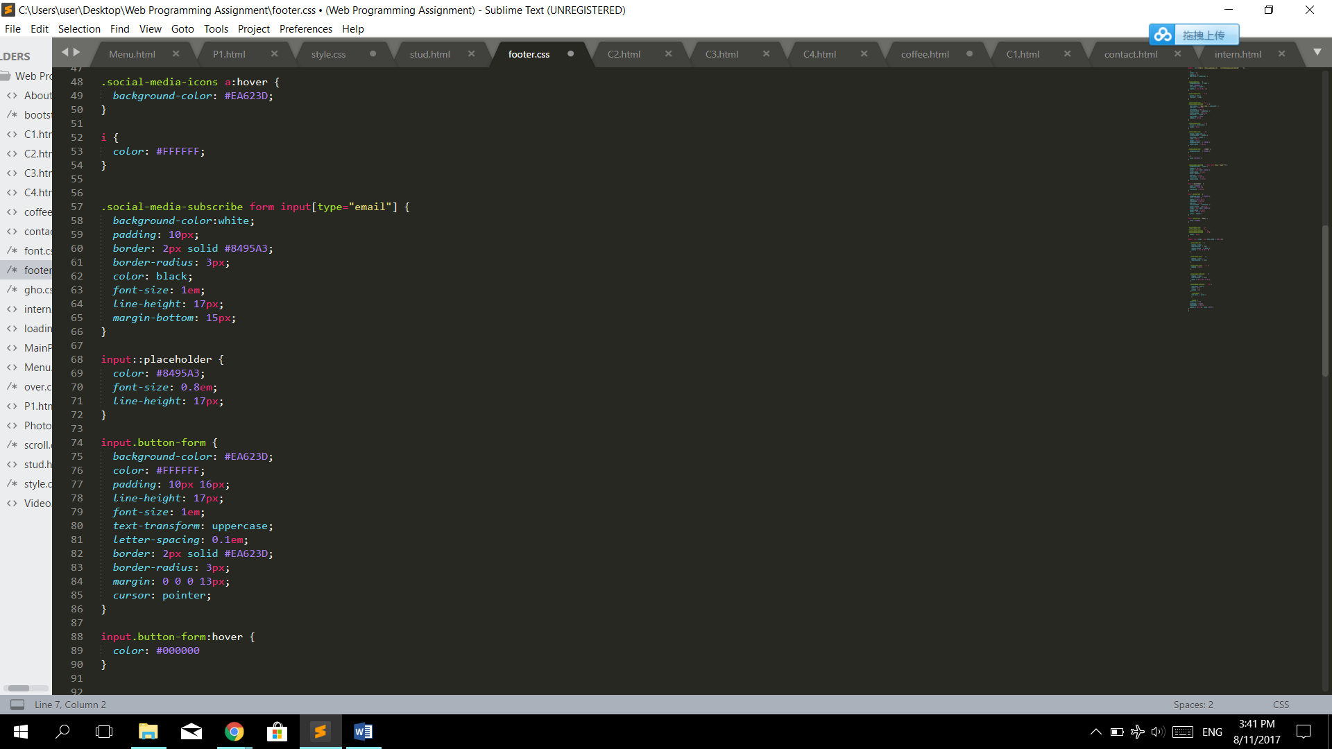

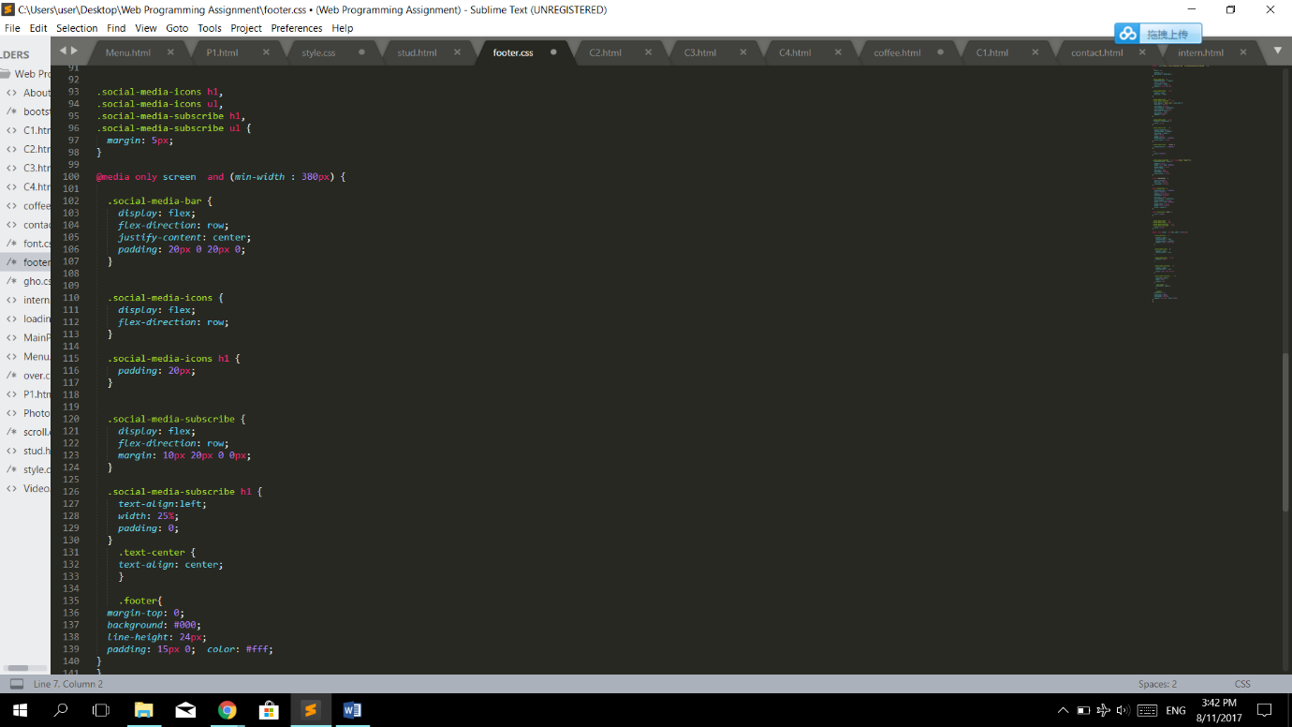

1. Btn-ghost(css)

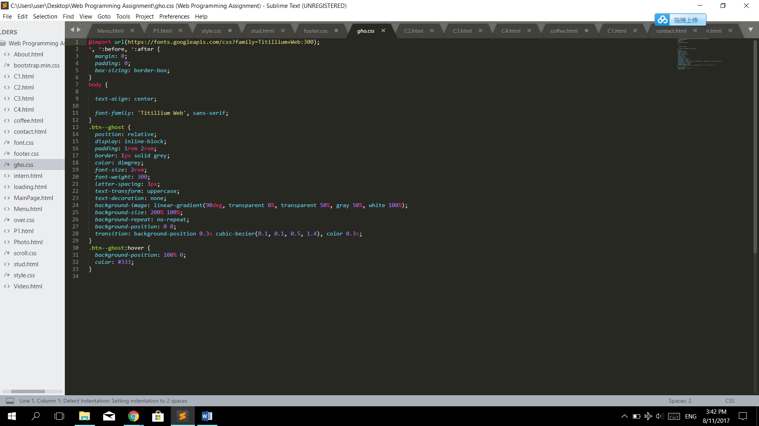

1. Iphone Hacks

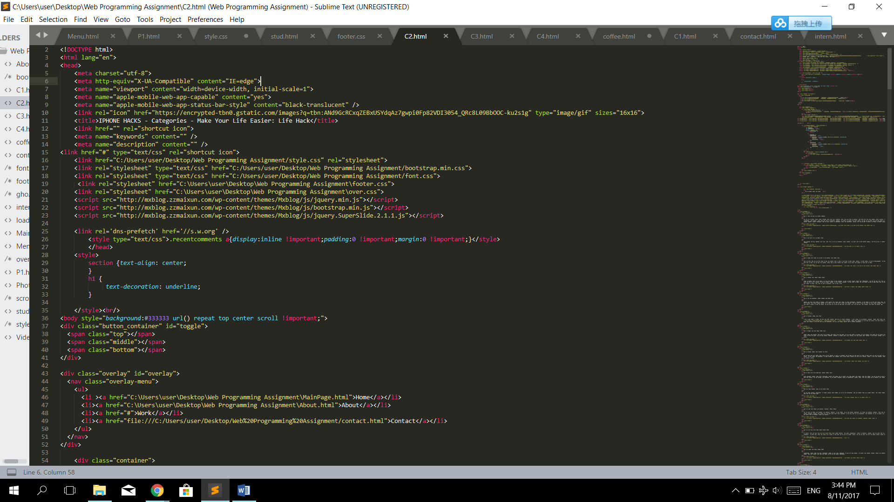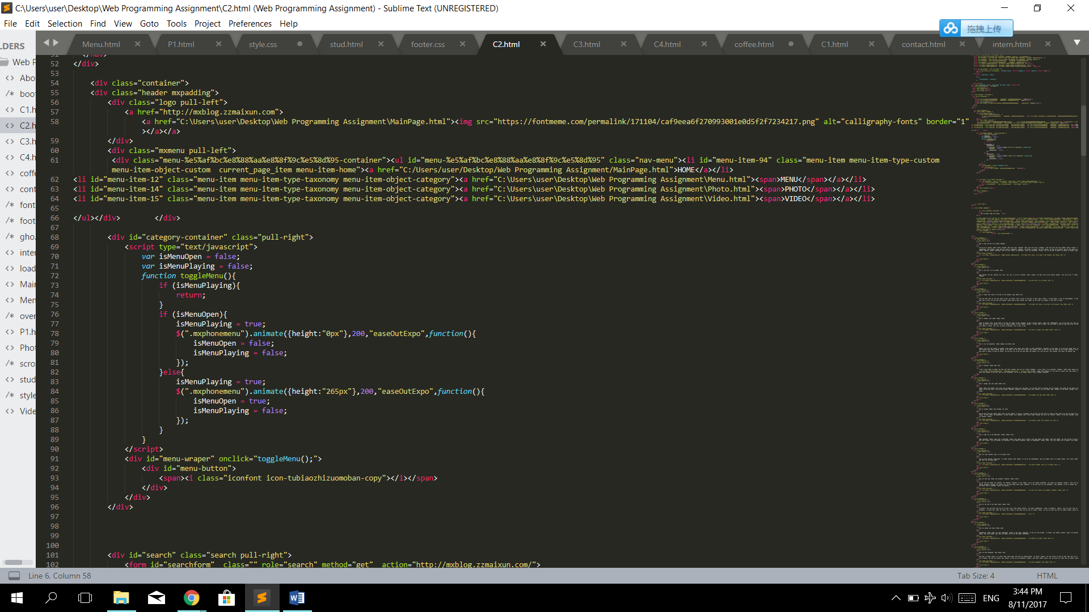

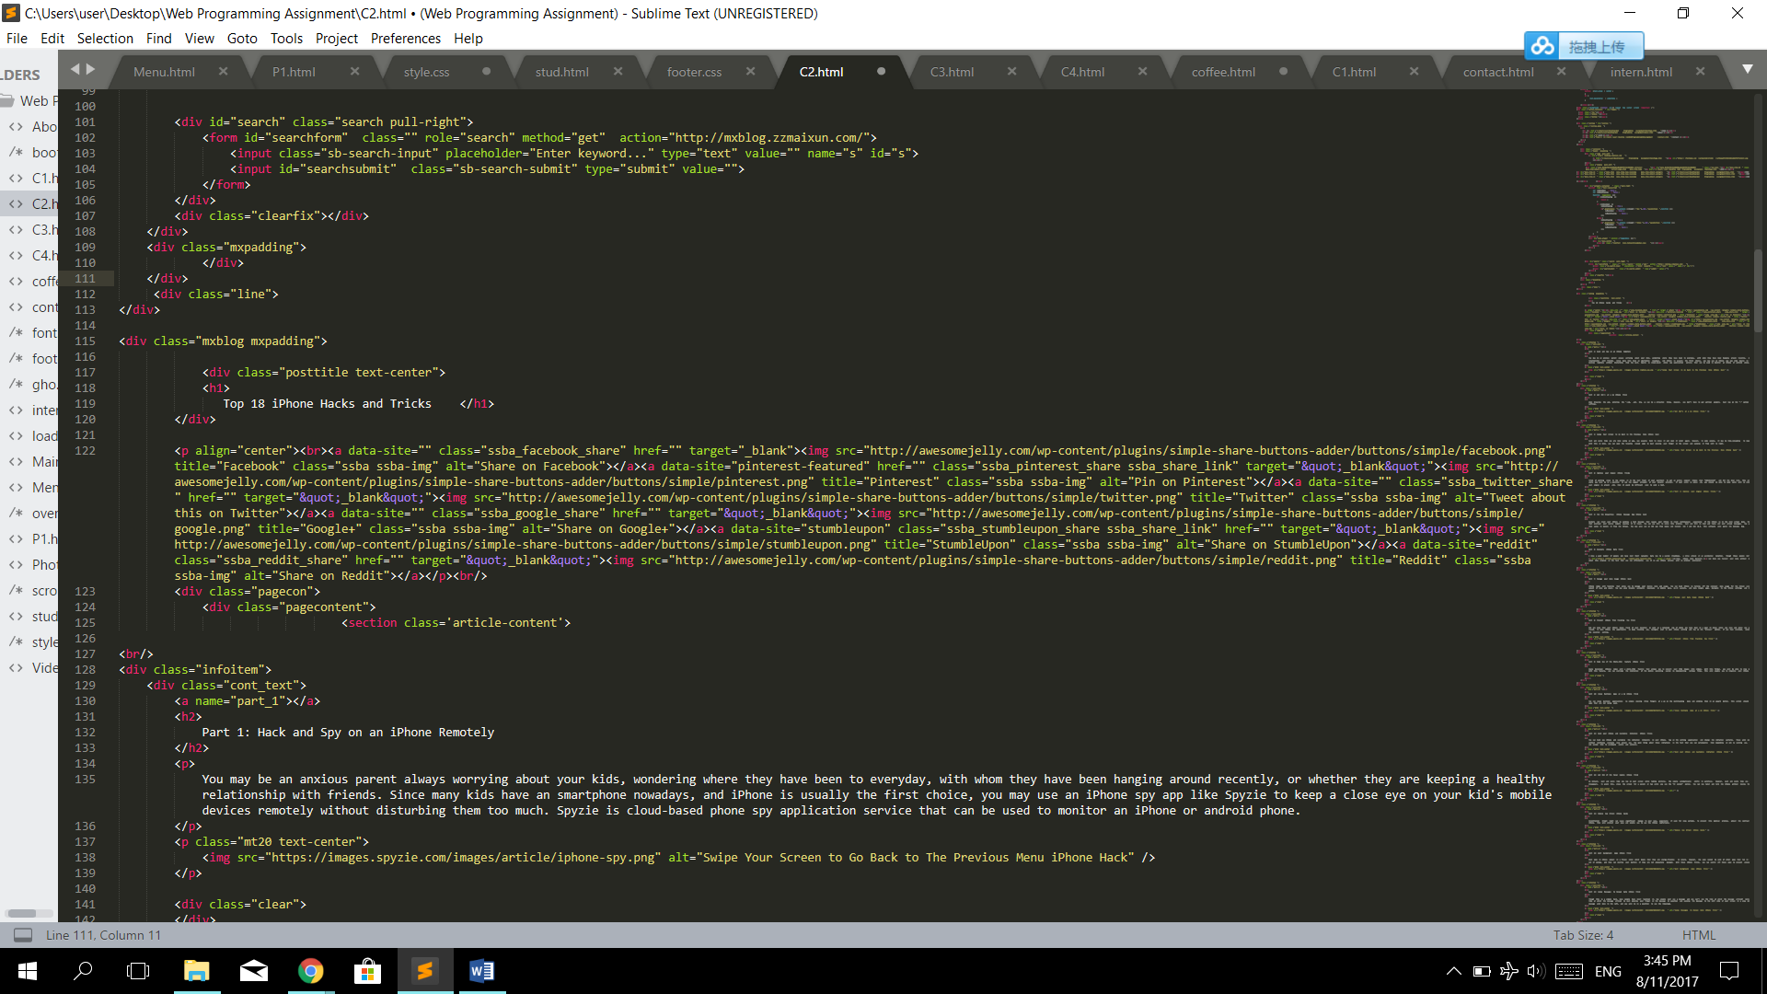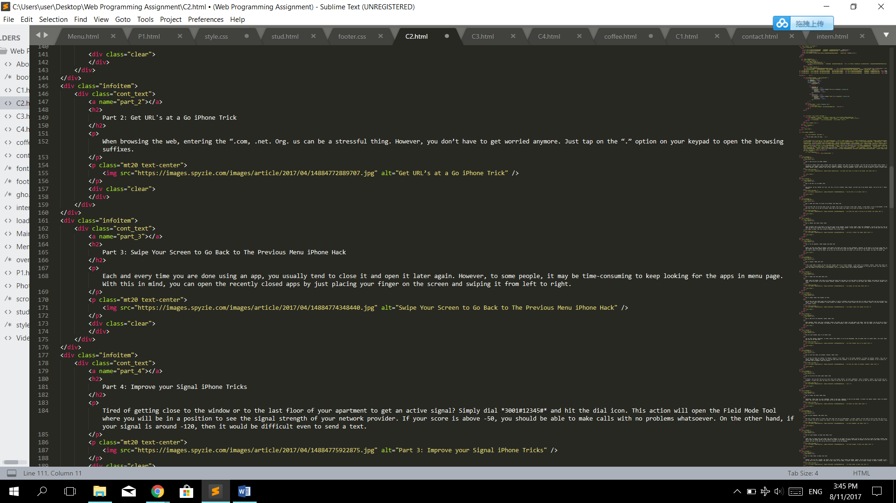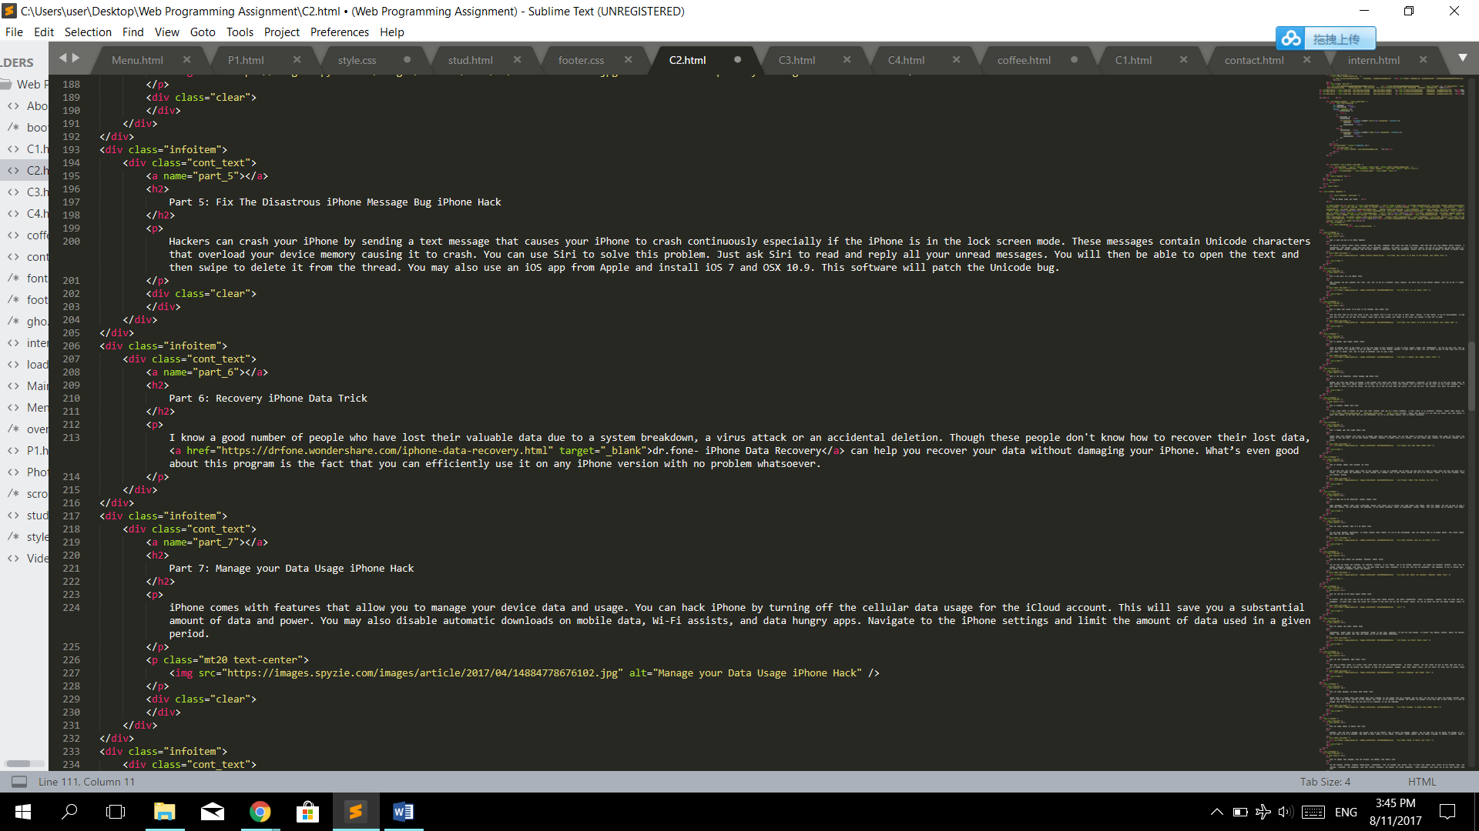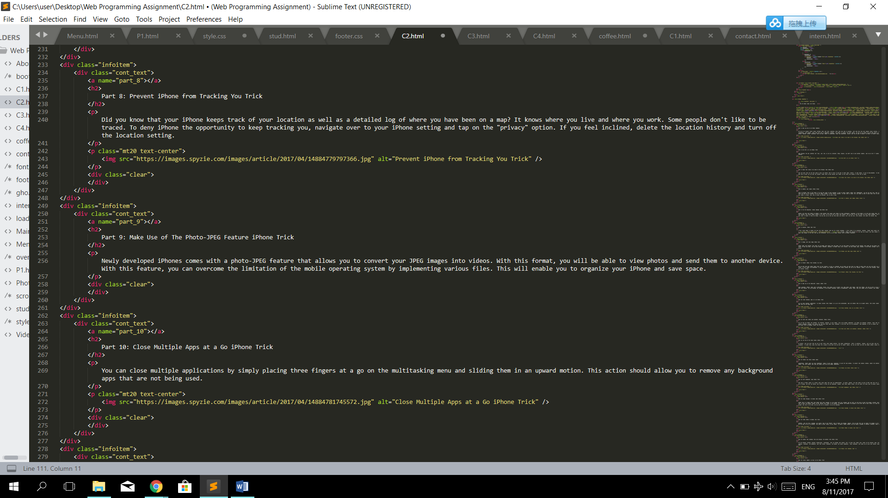

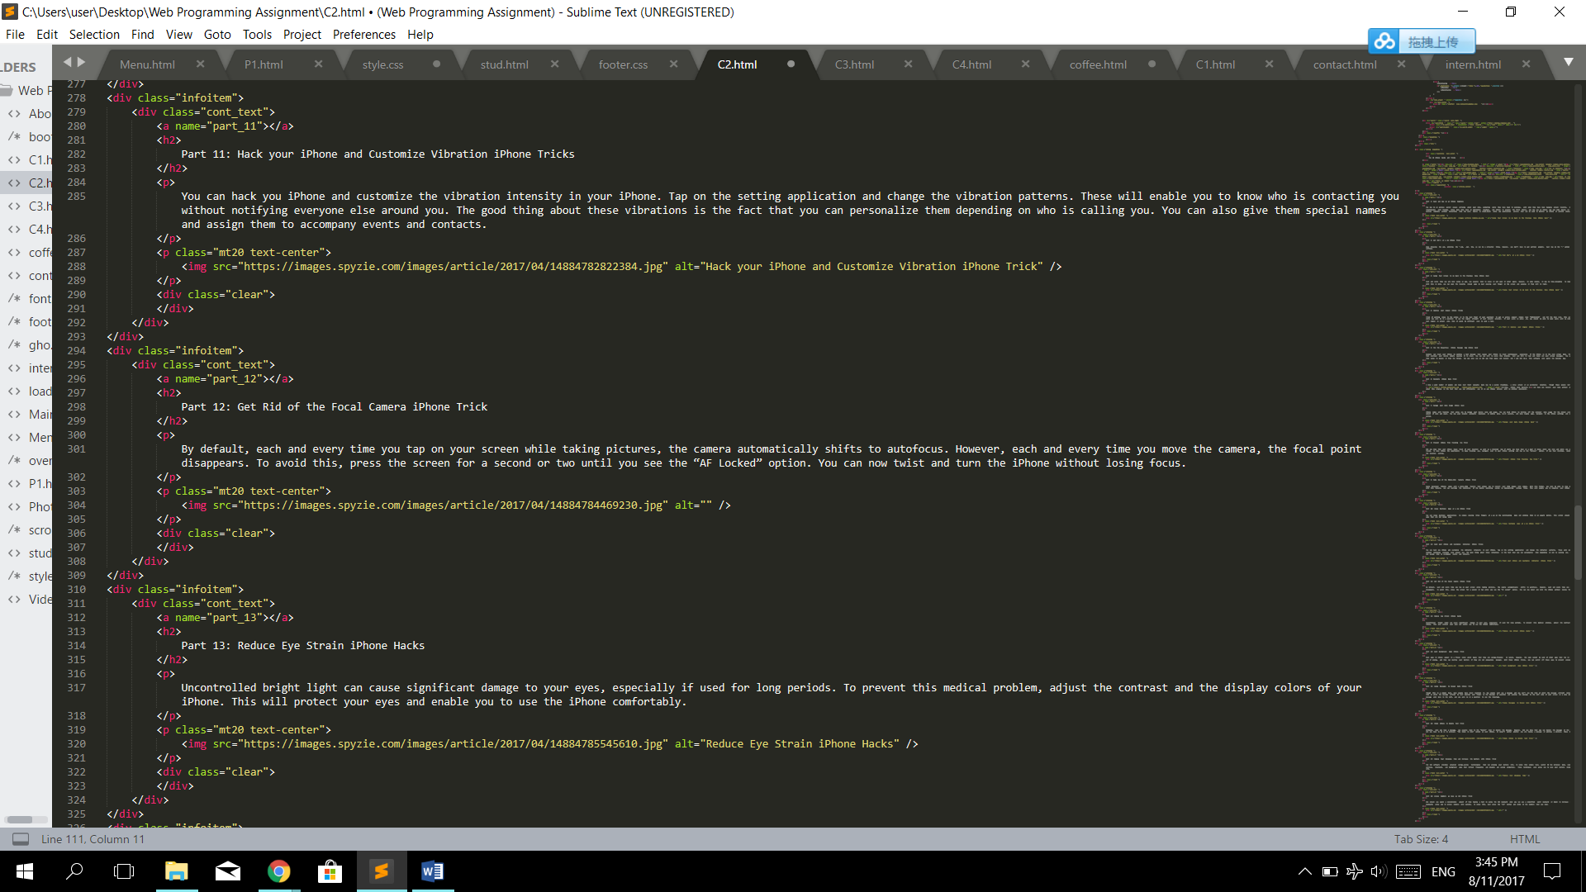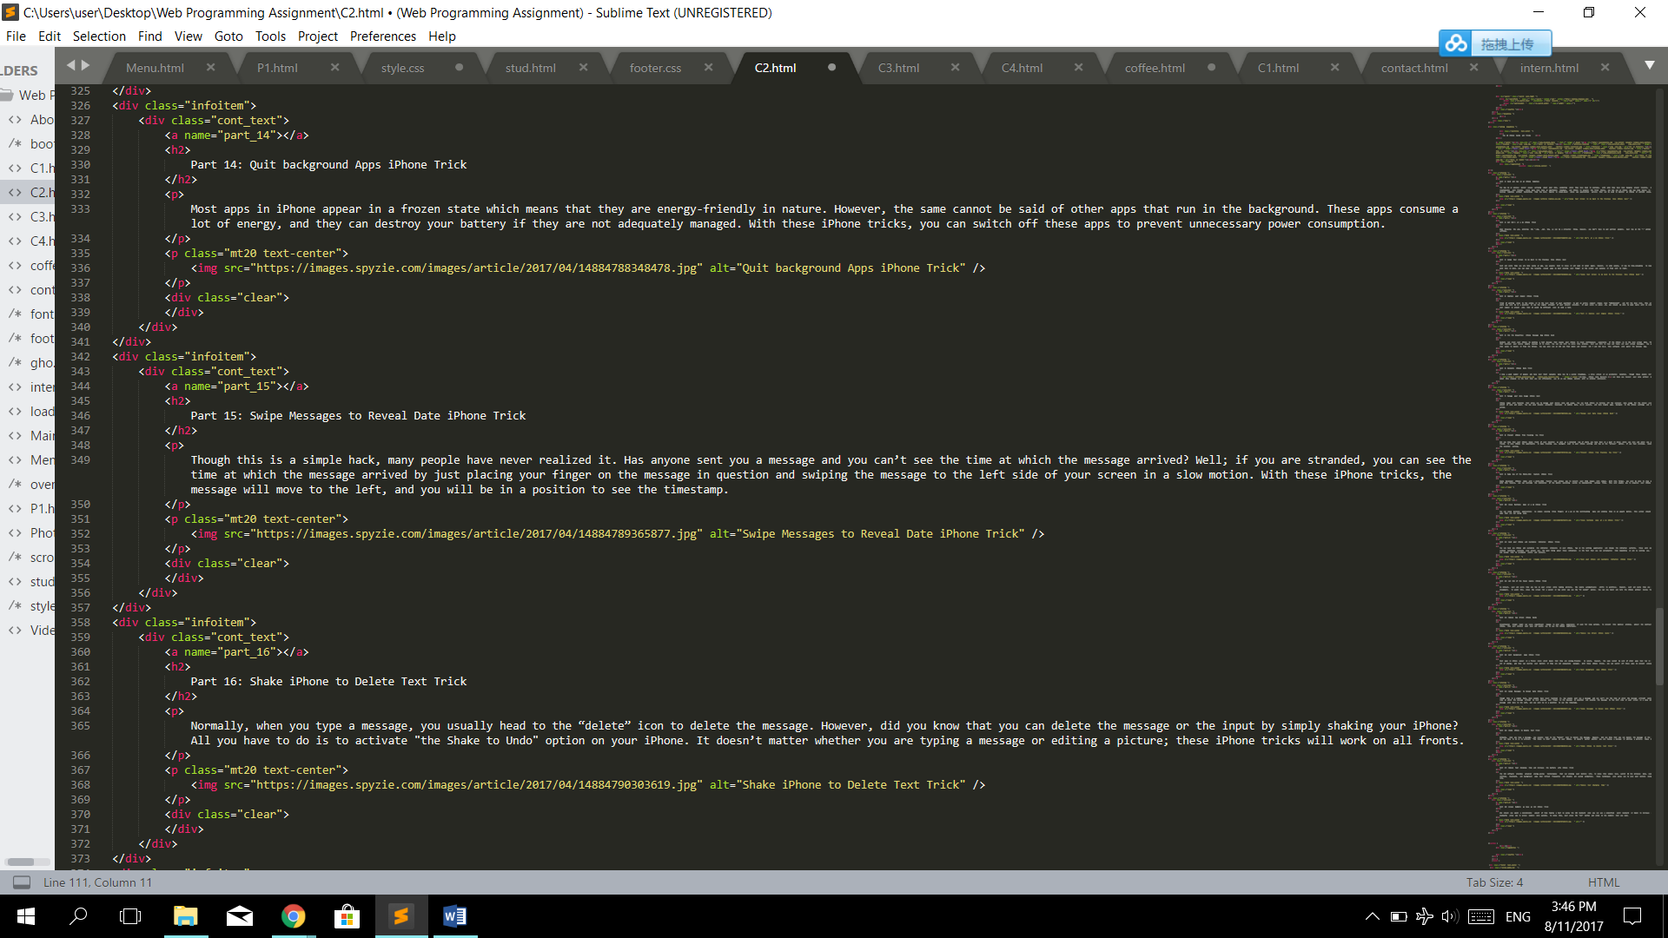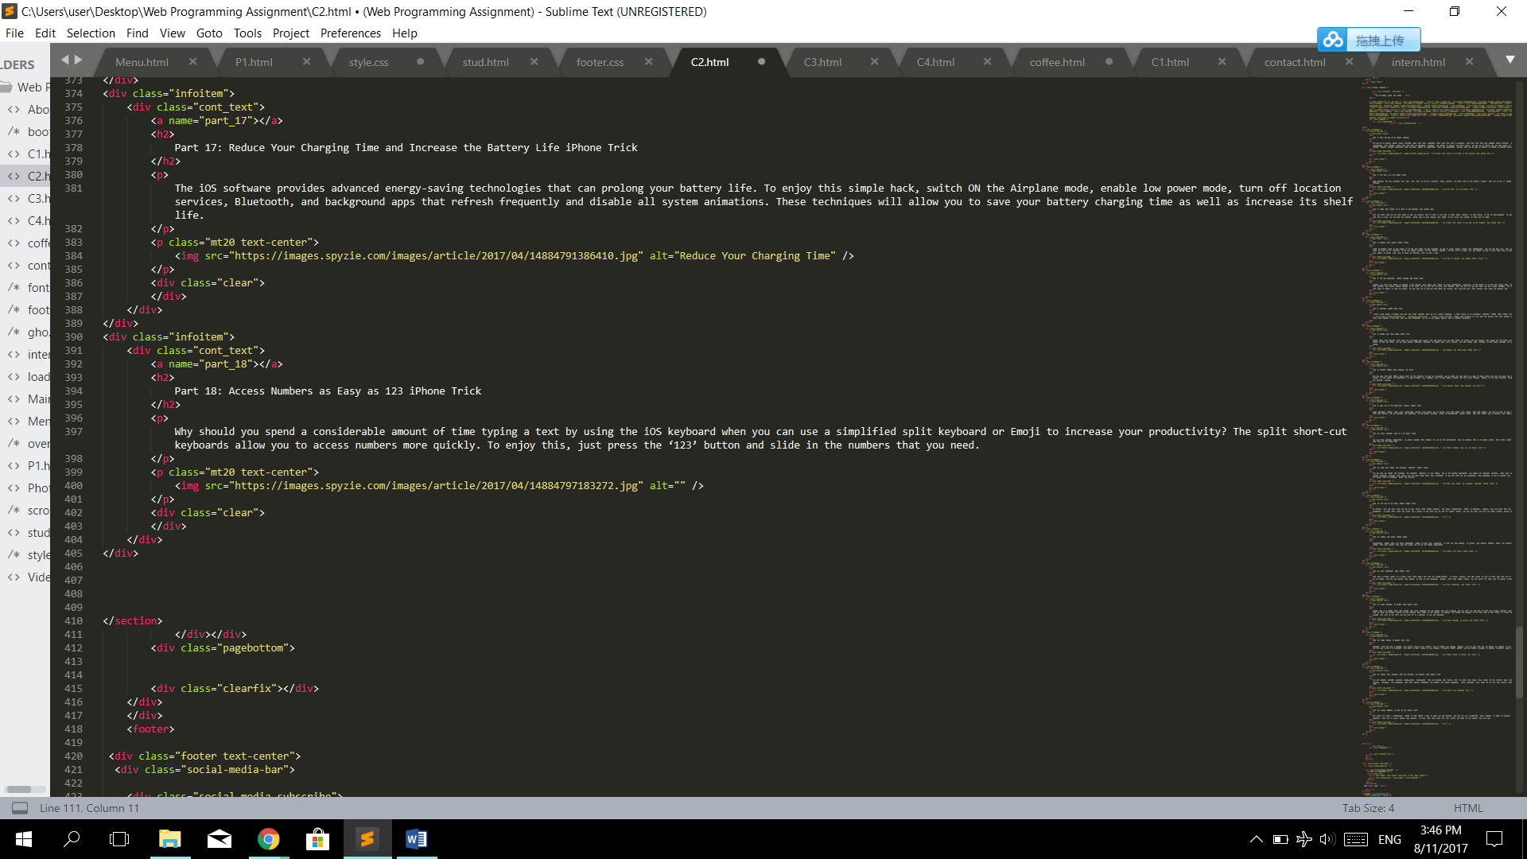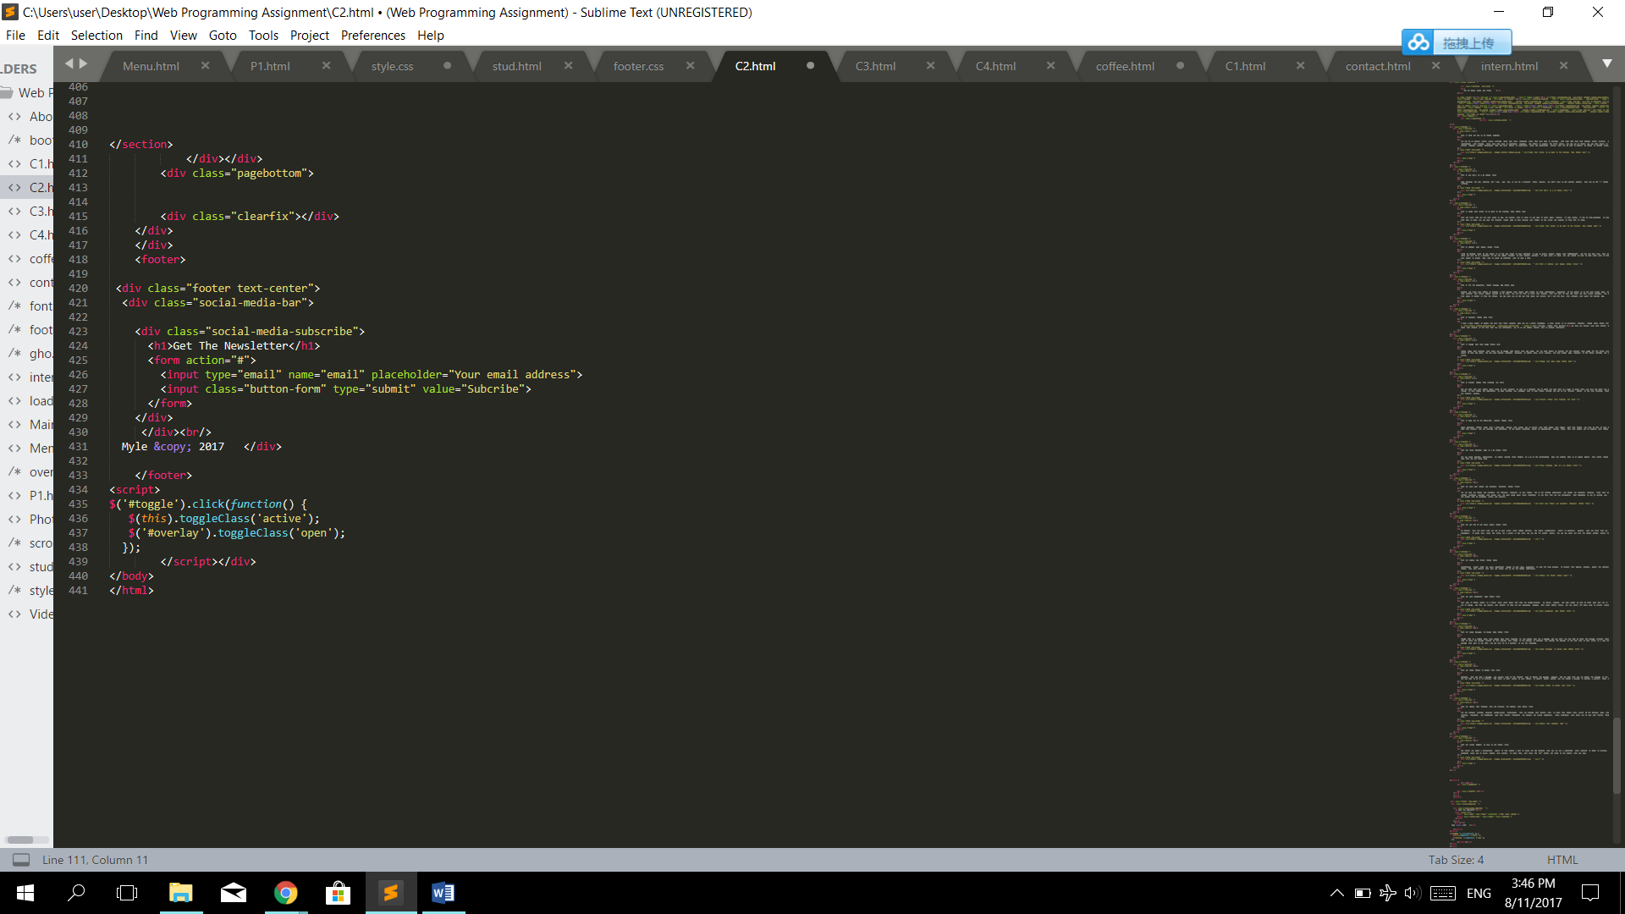

1. Office

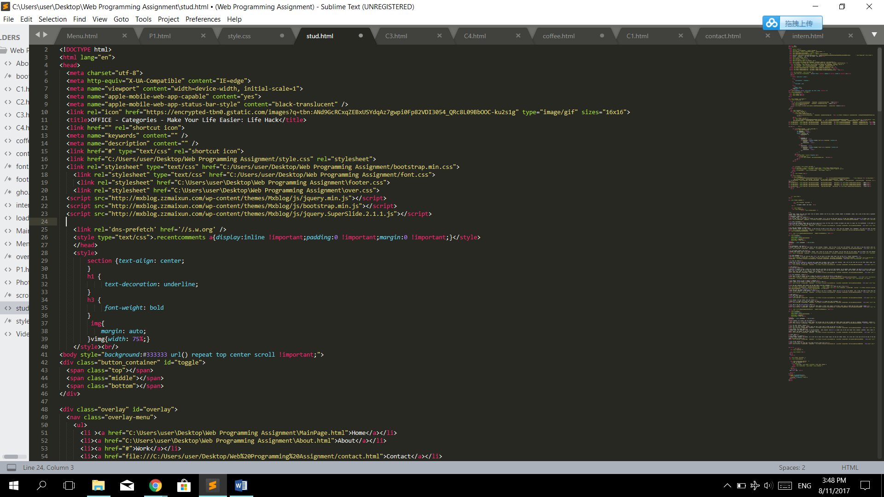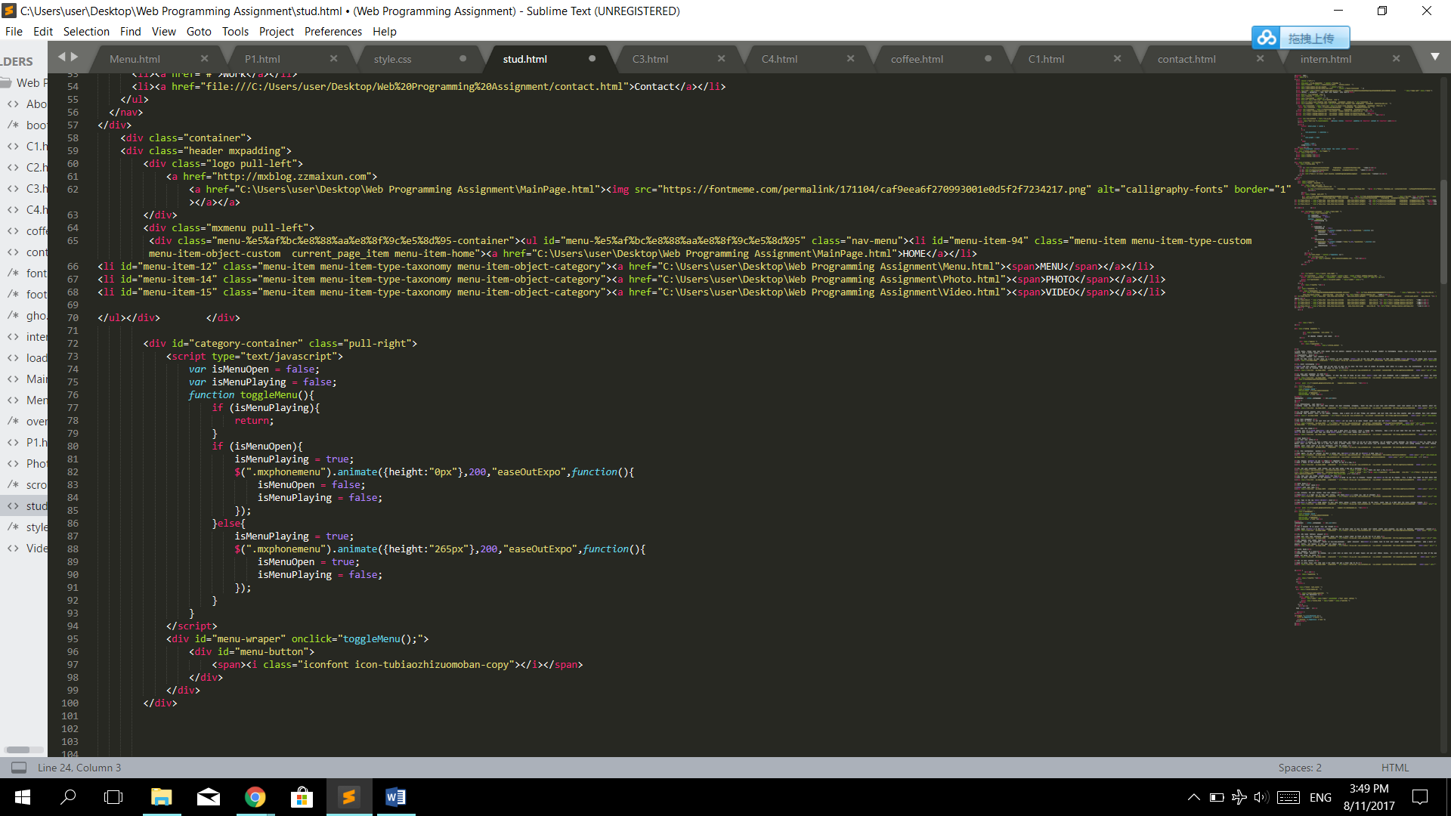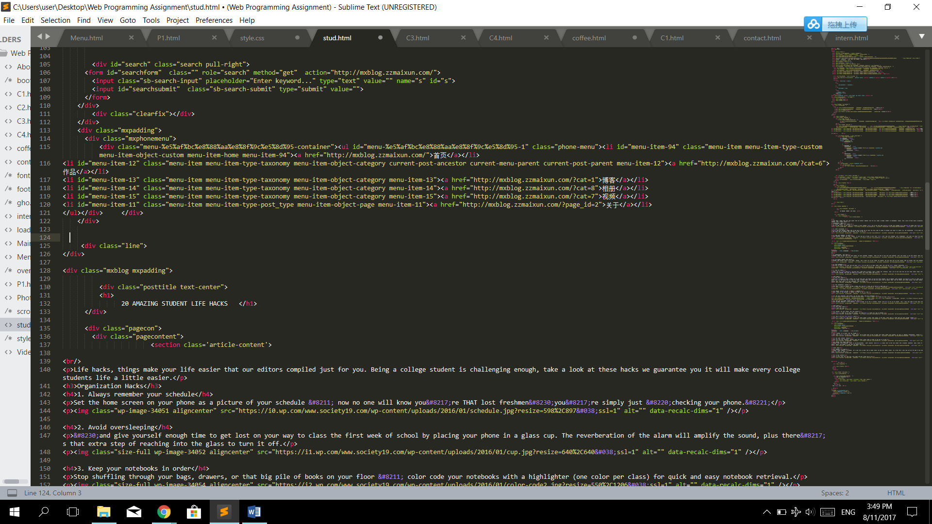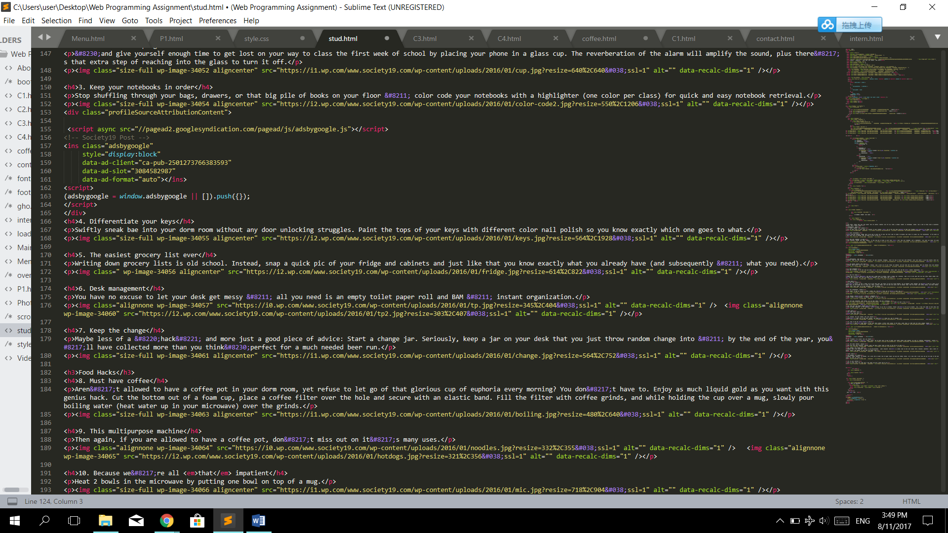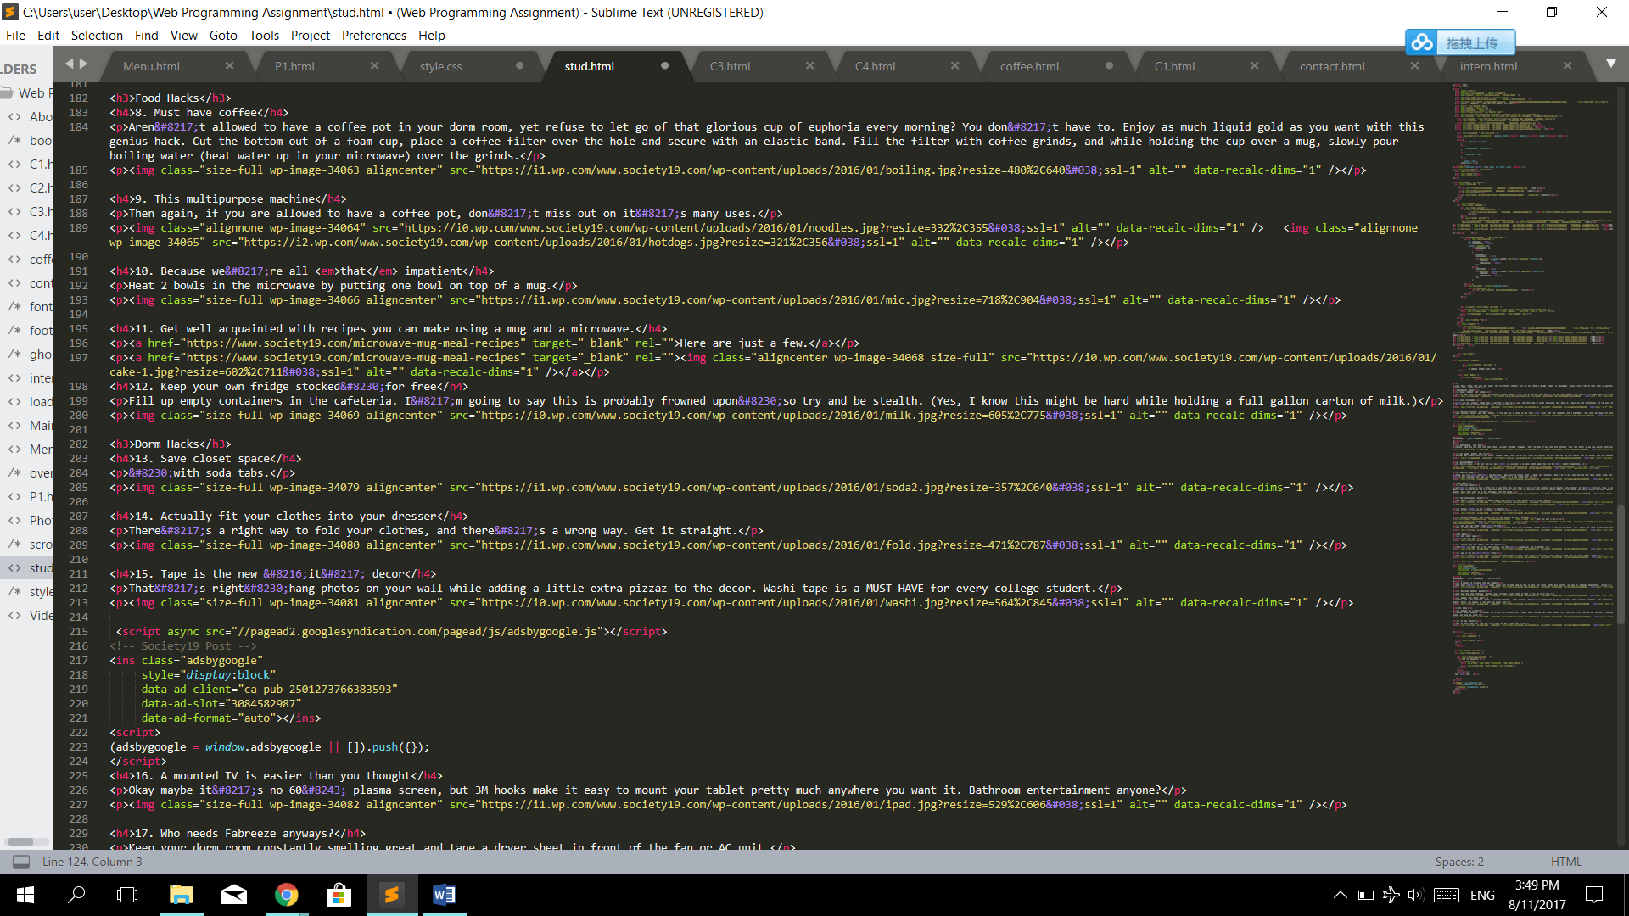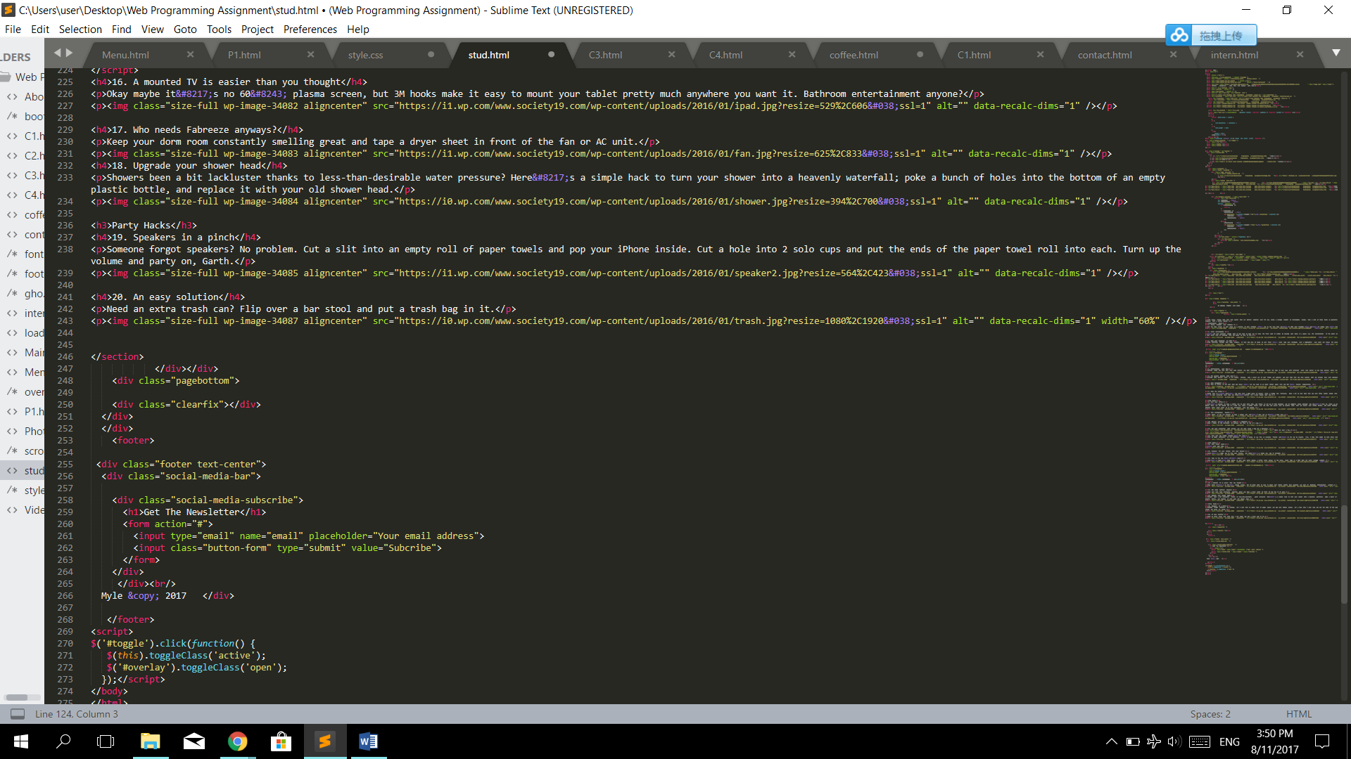

1. Student

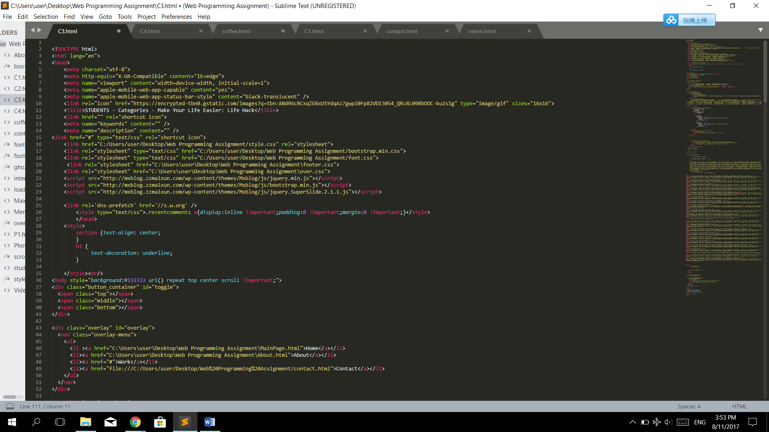

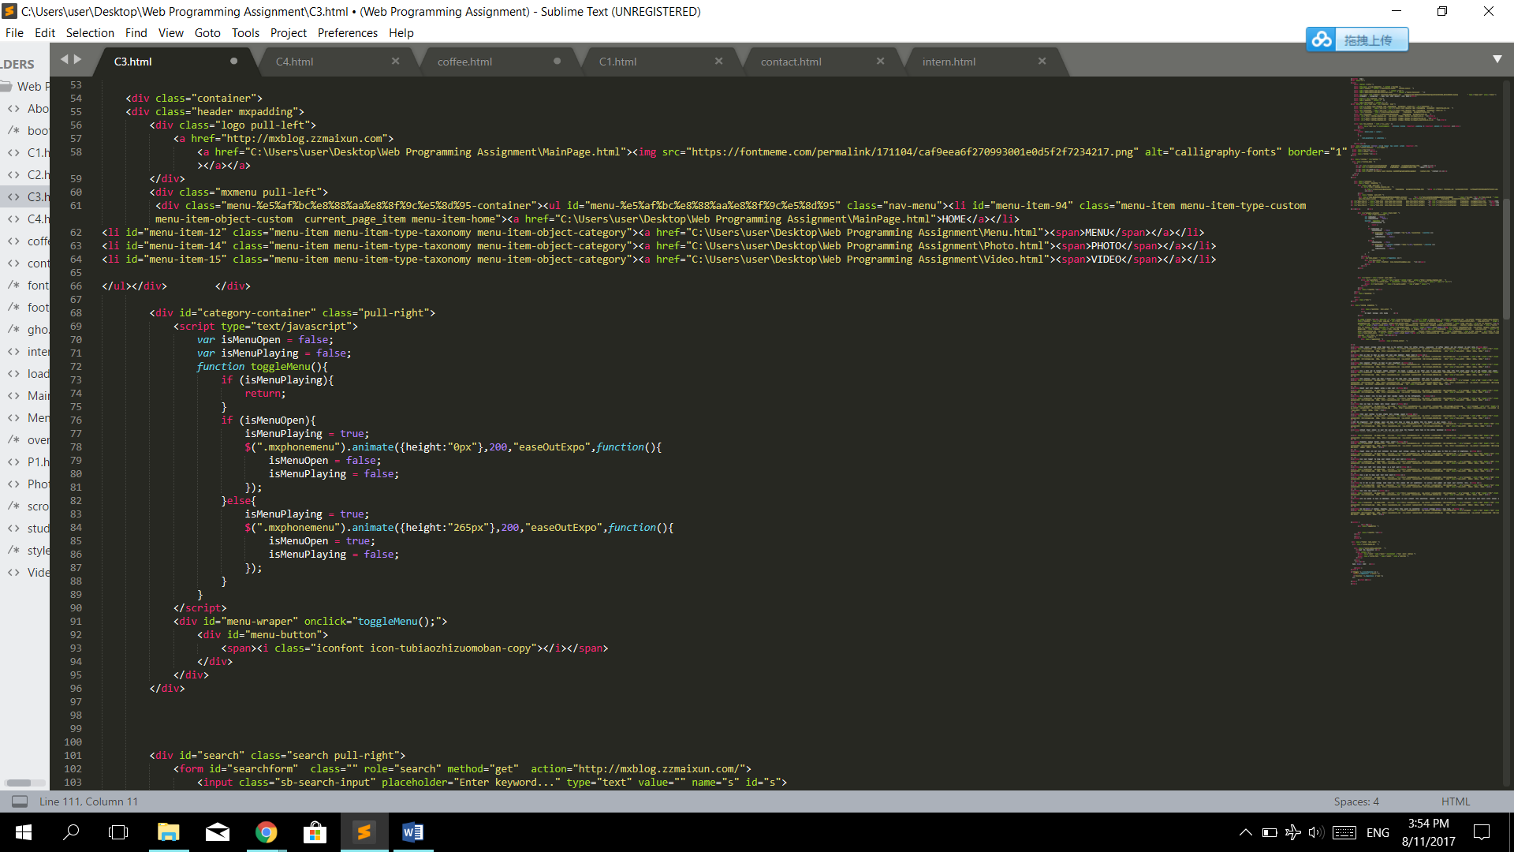

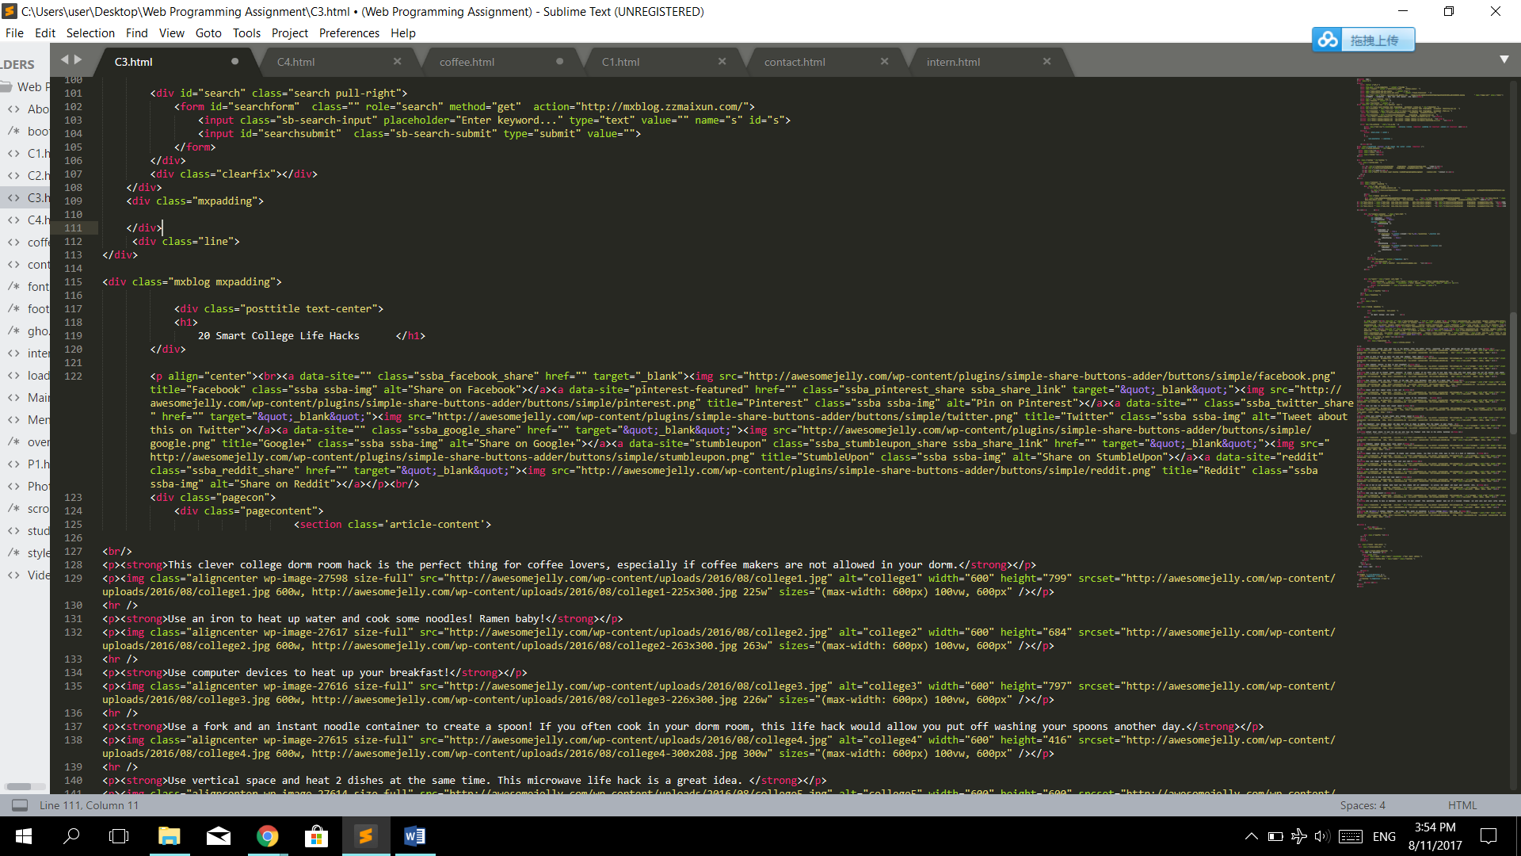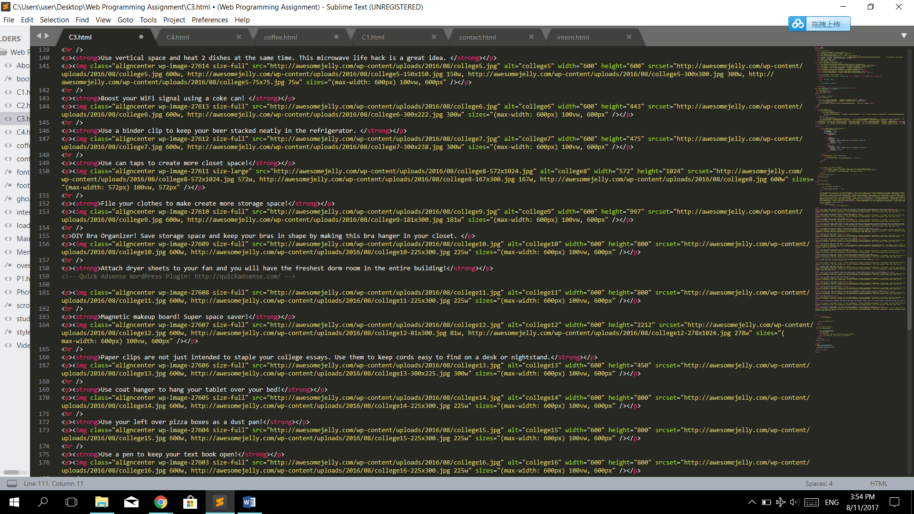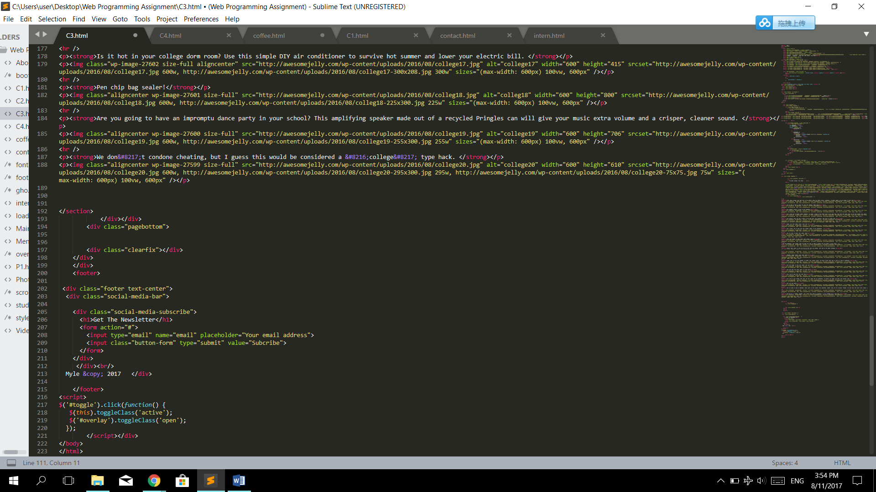

1. Party

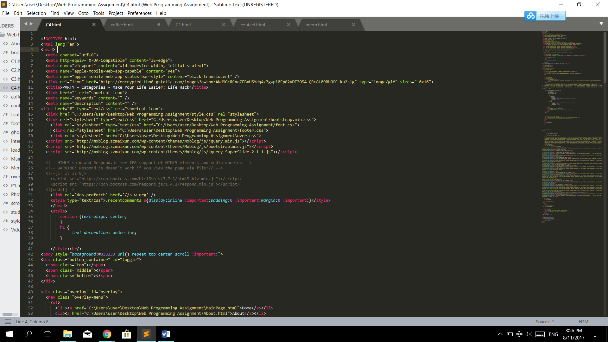

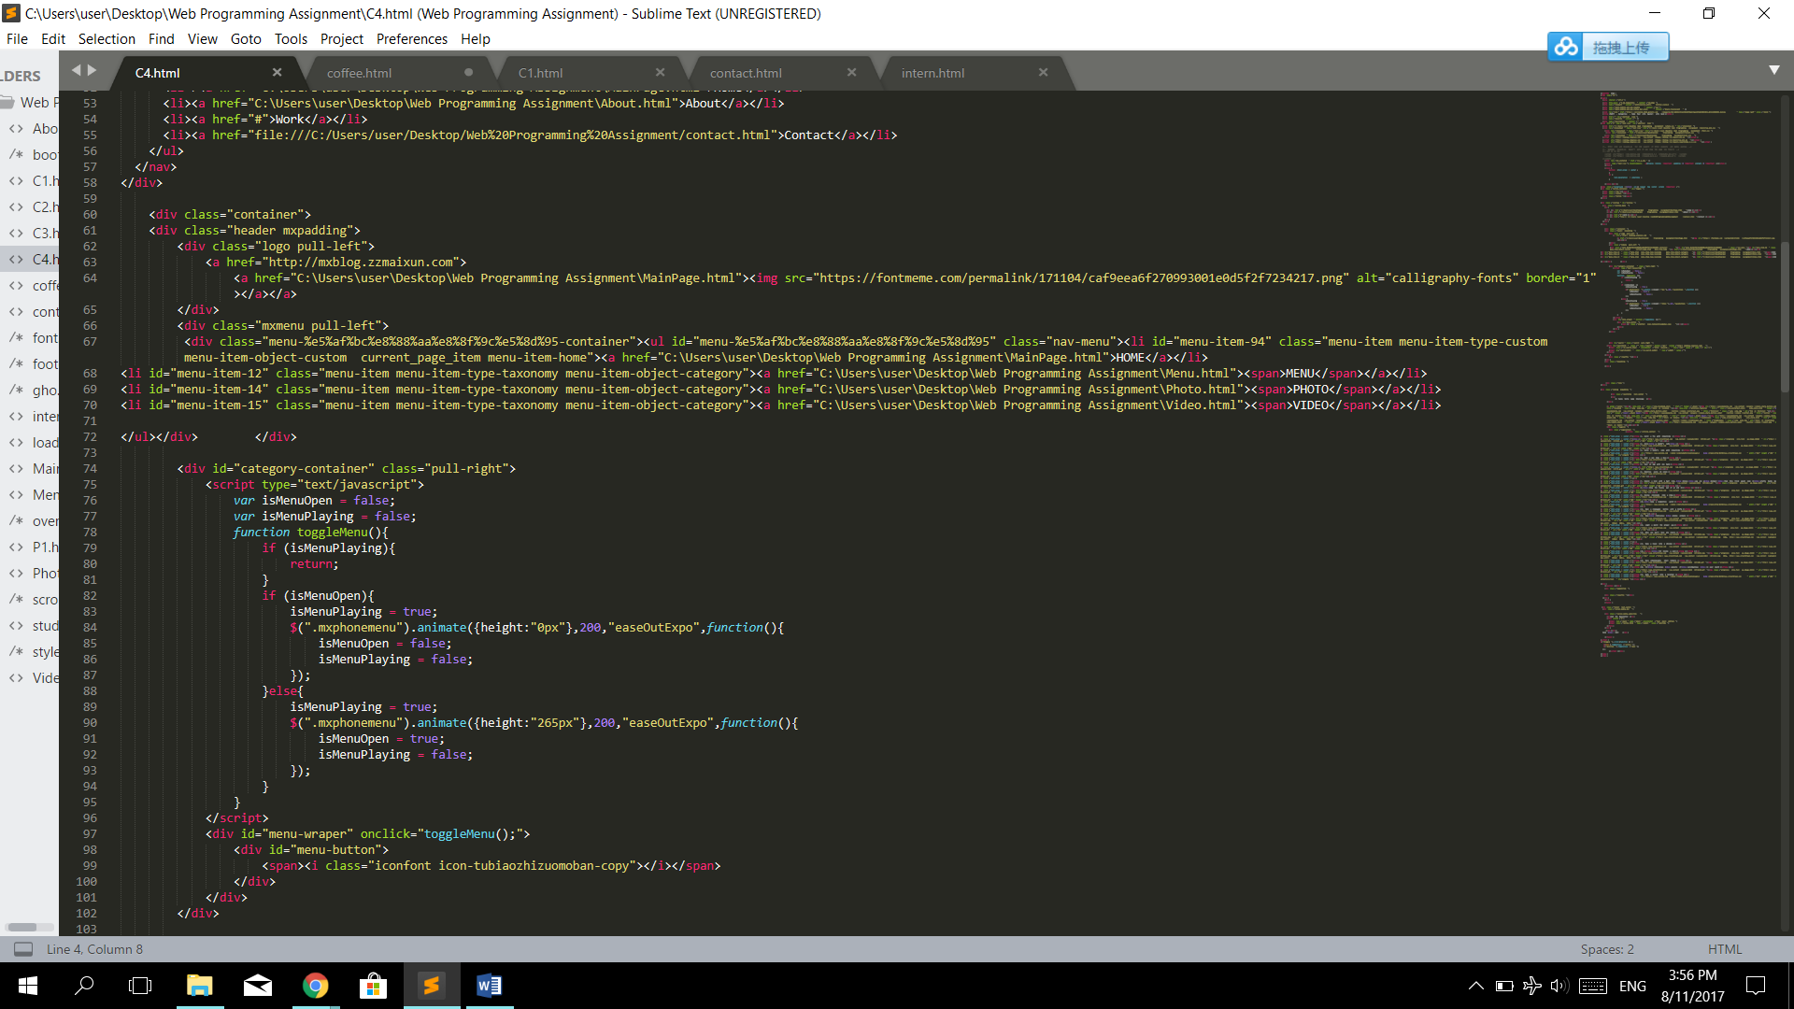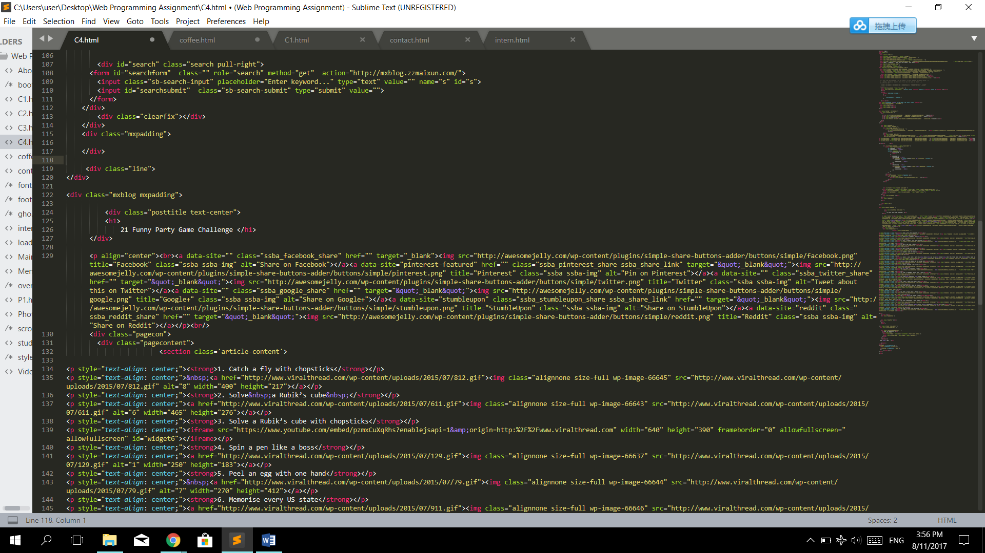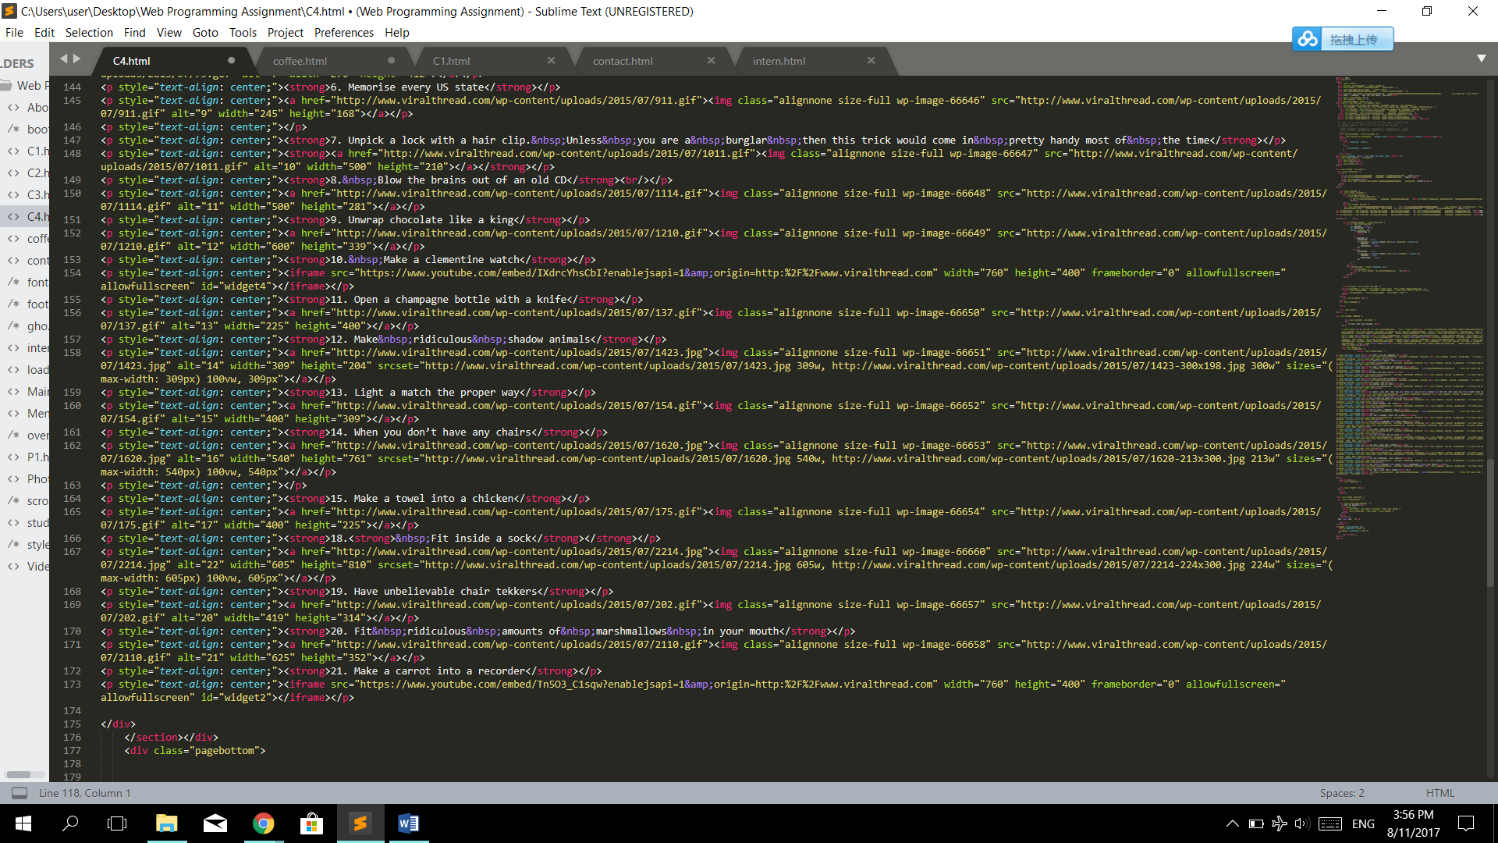

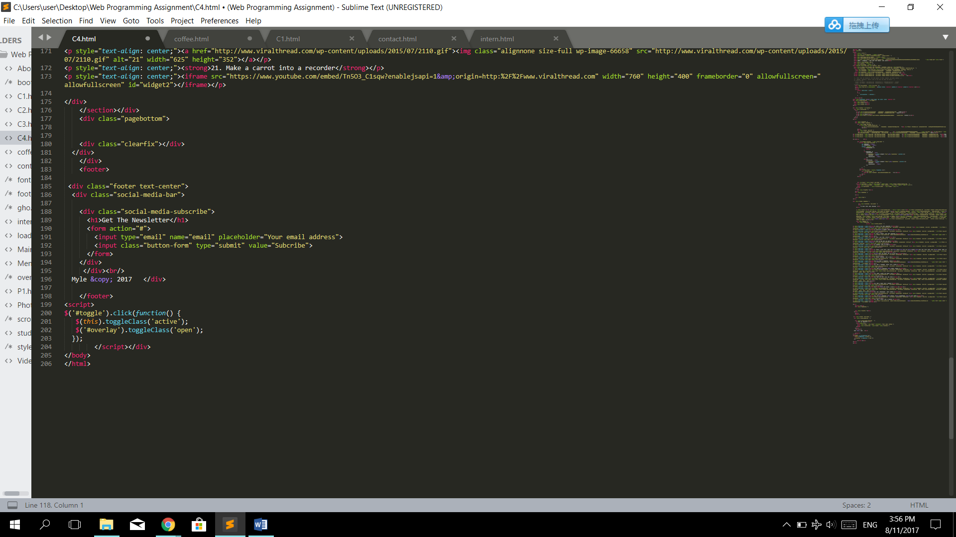

1. Contact

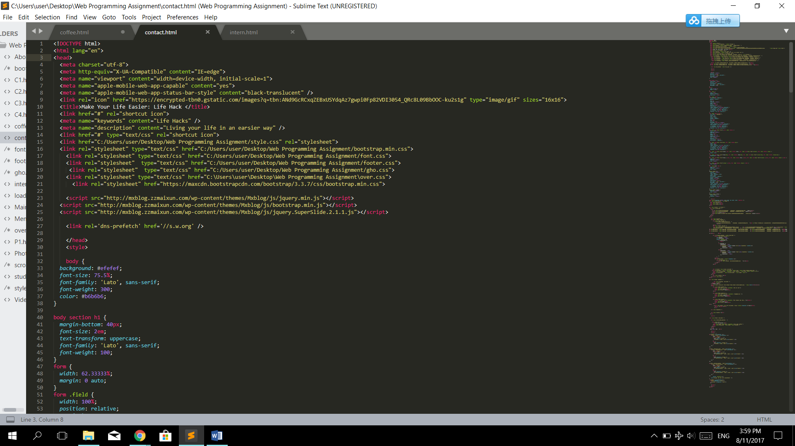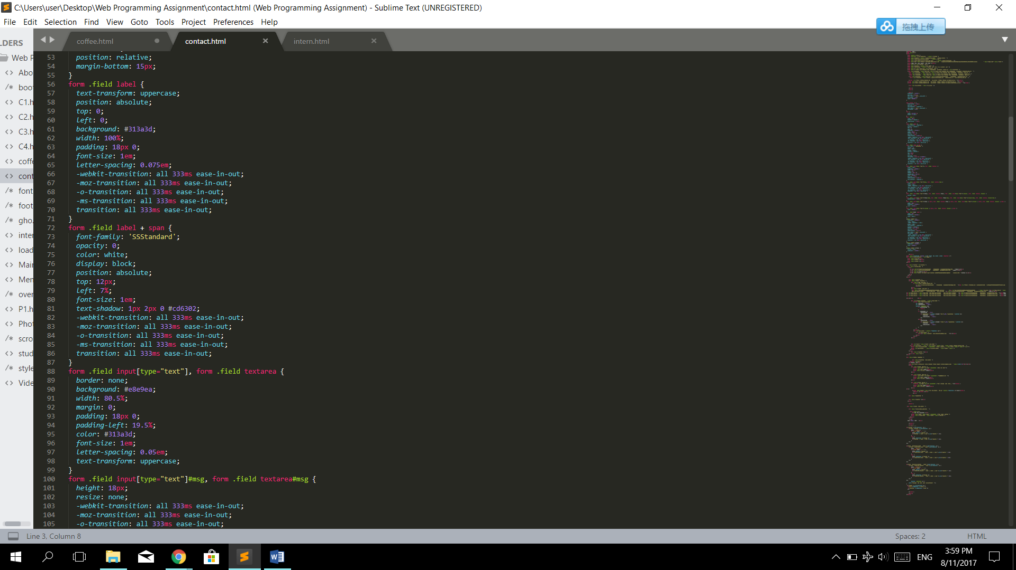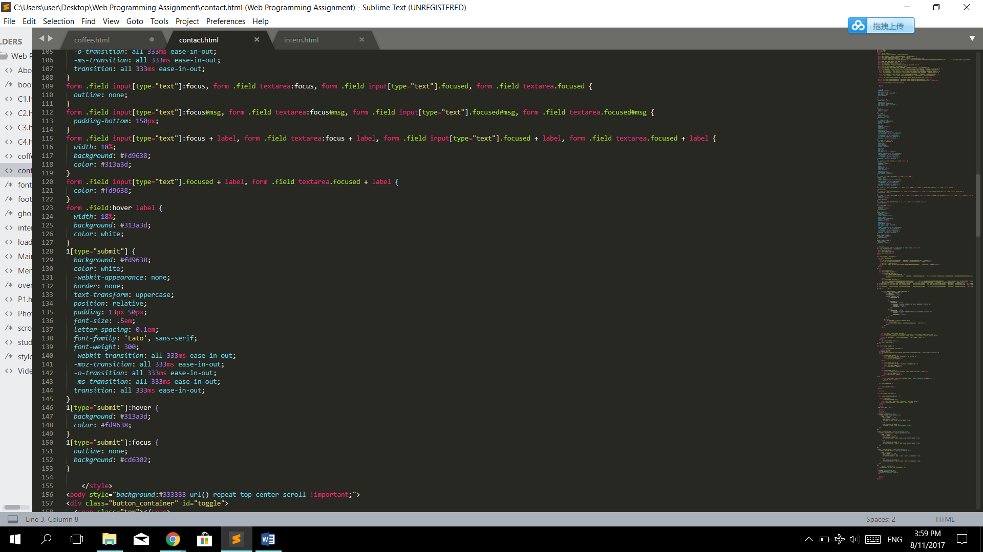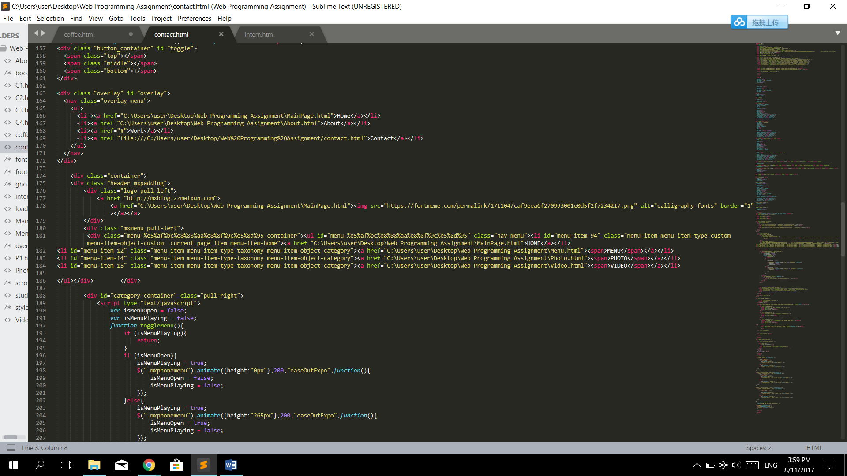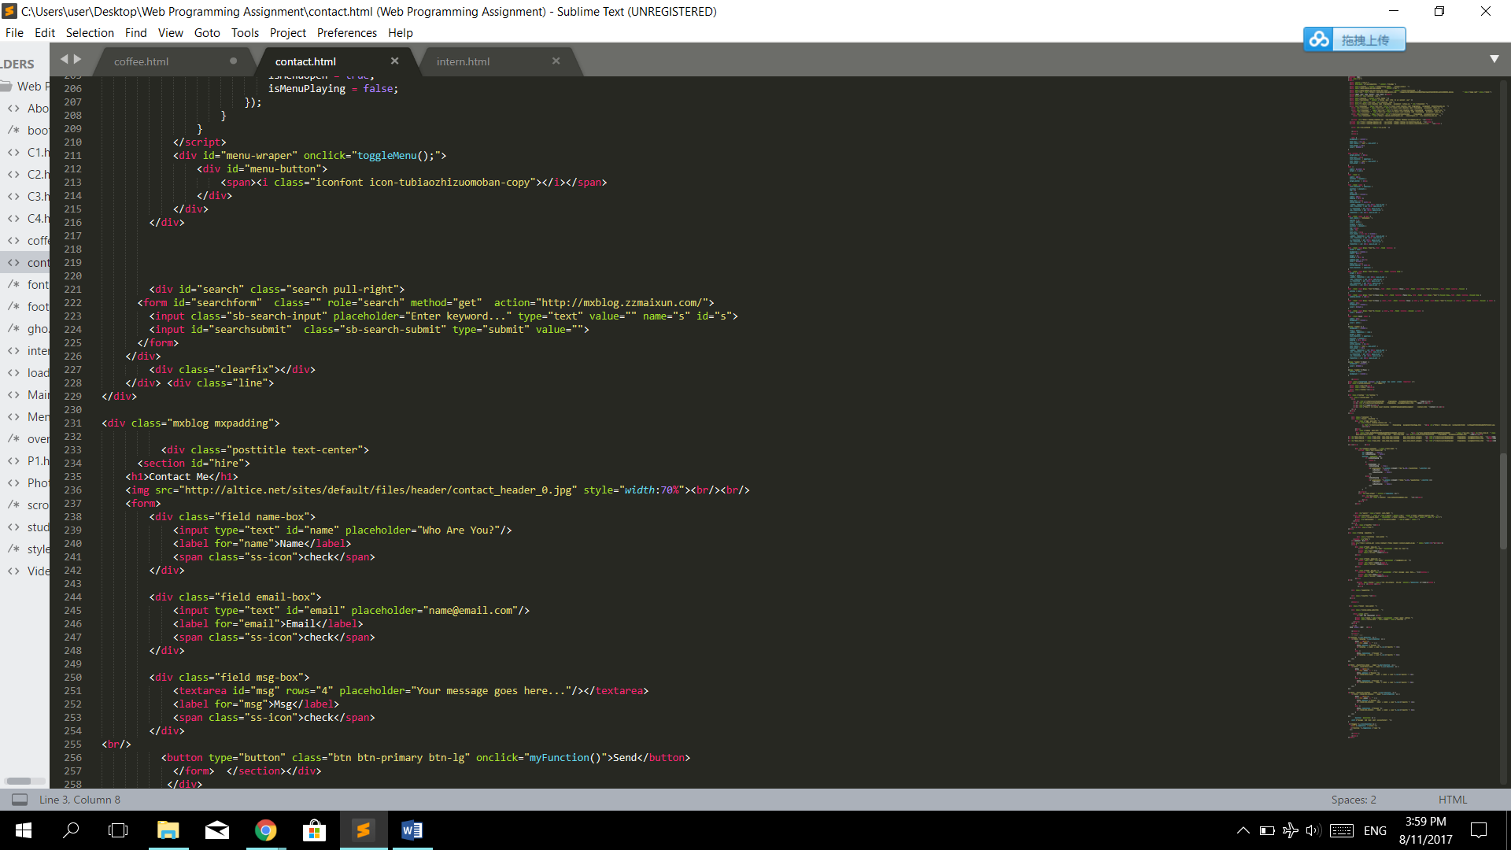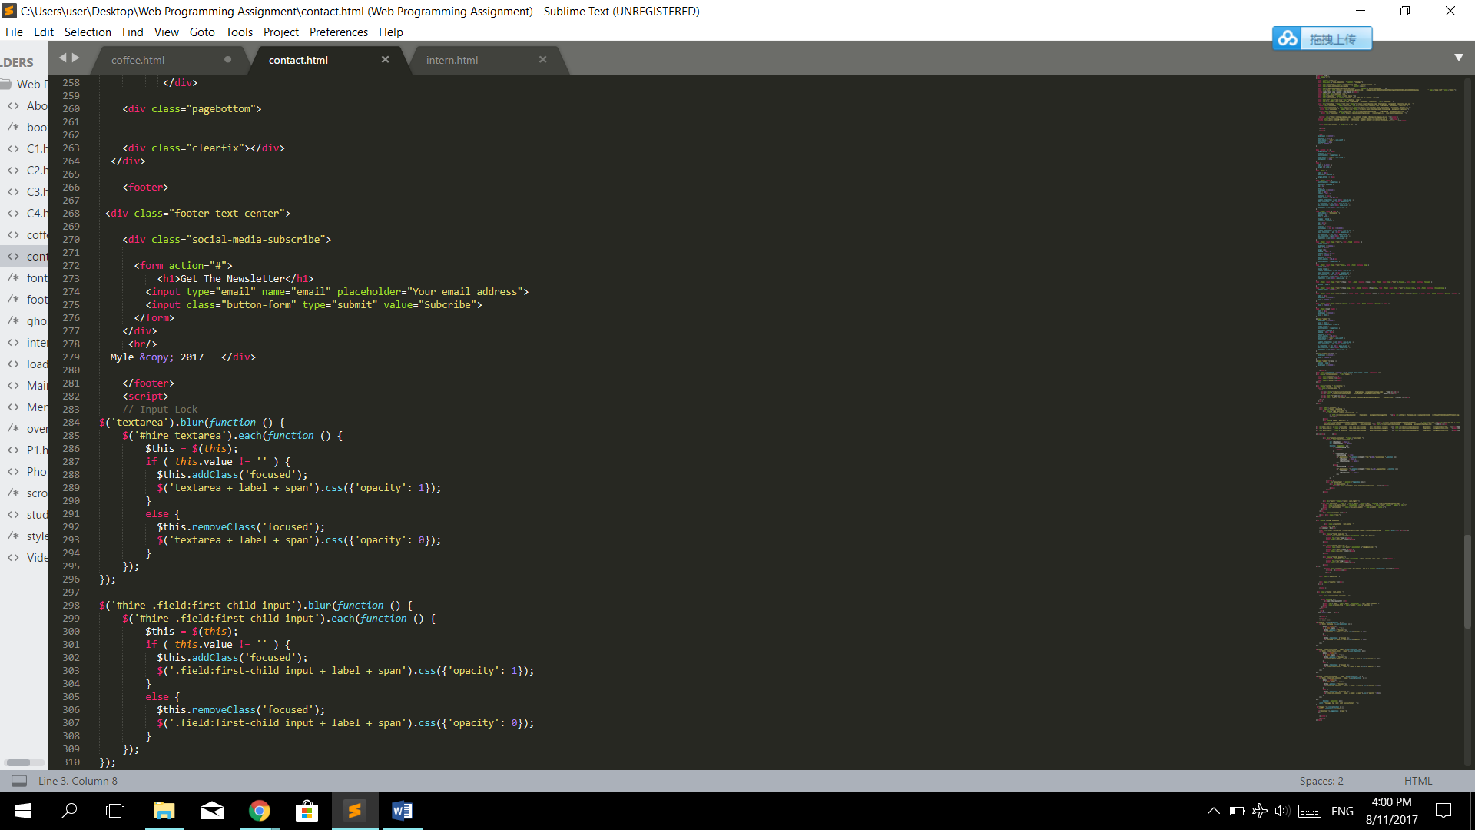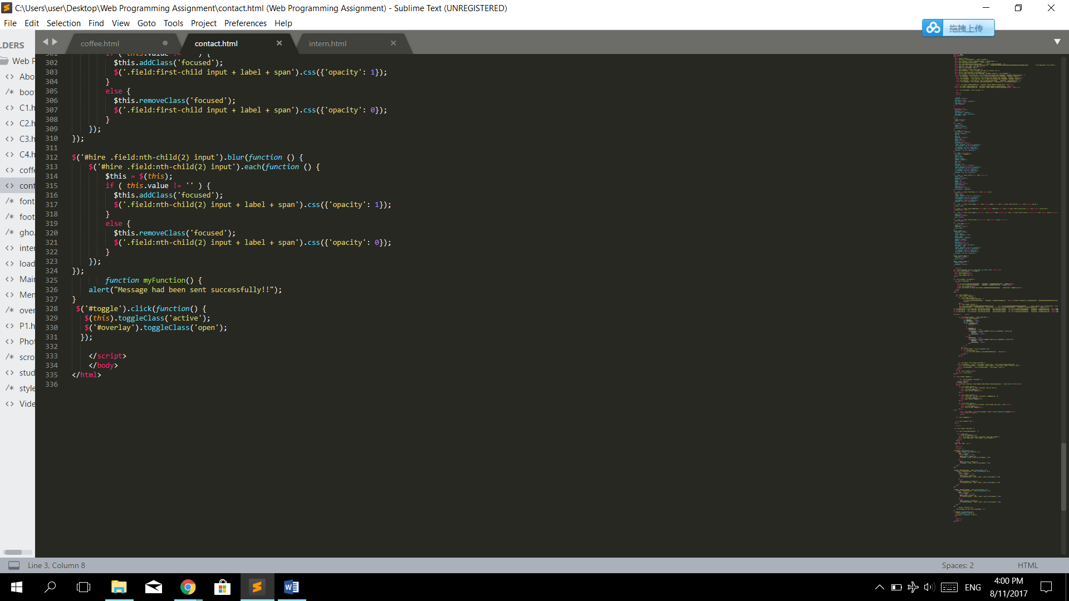

1. Interns

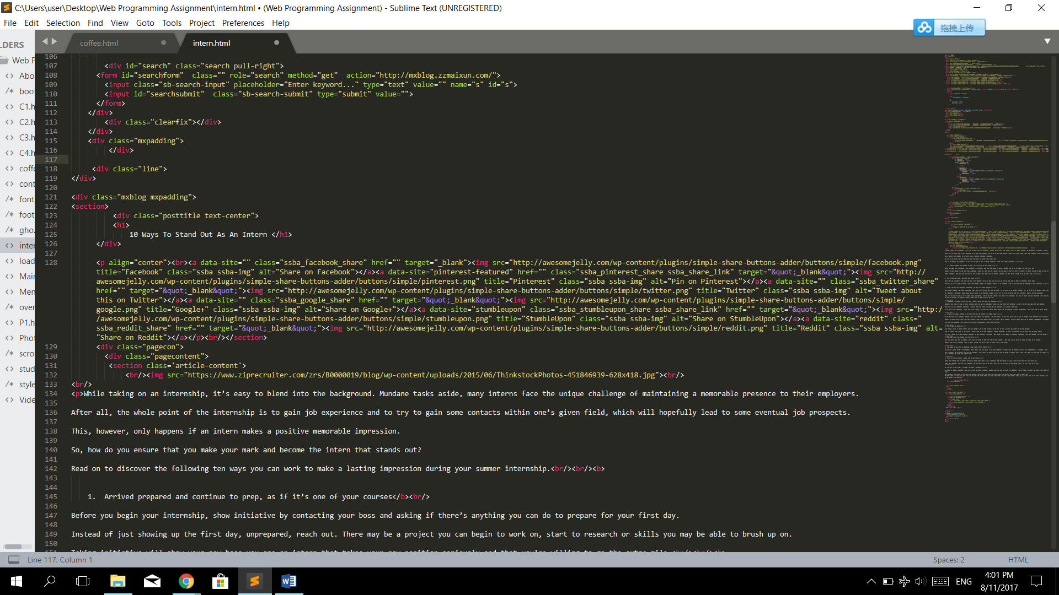

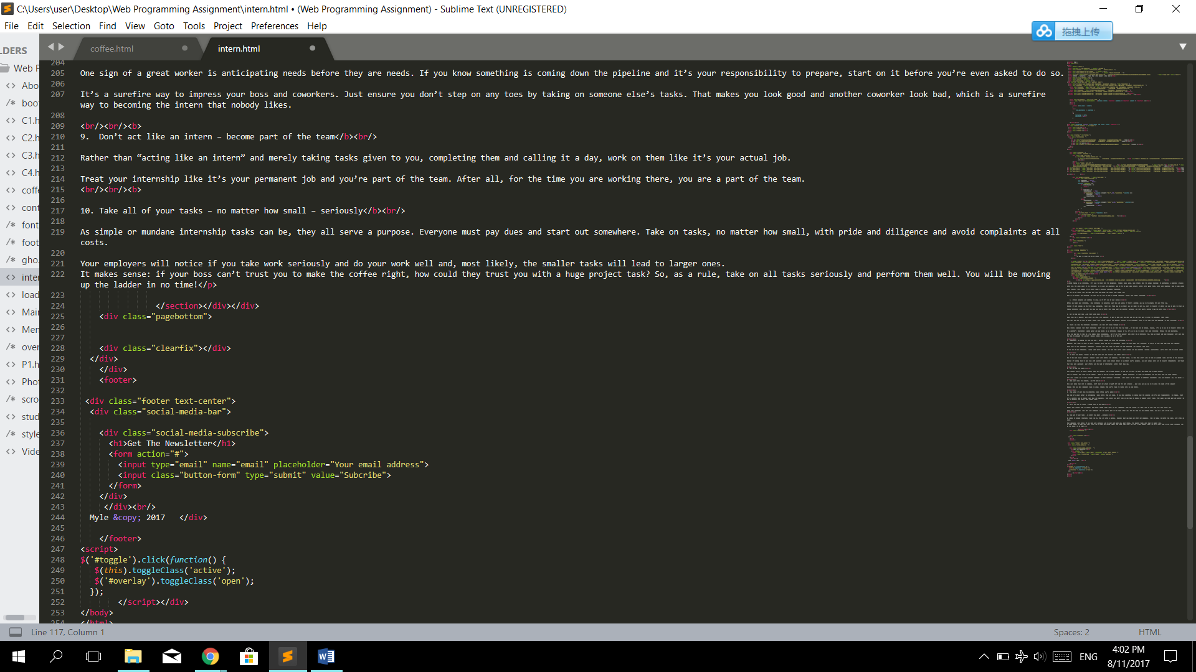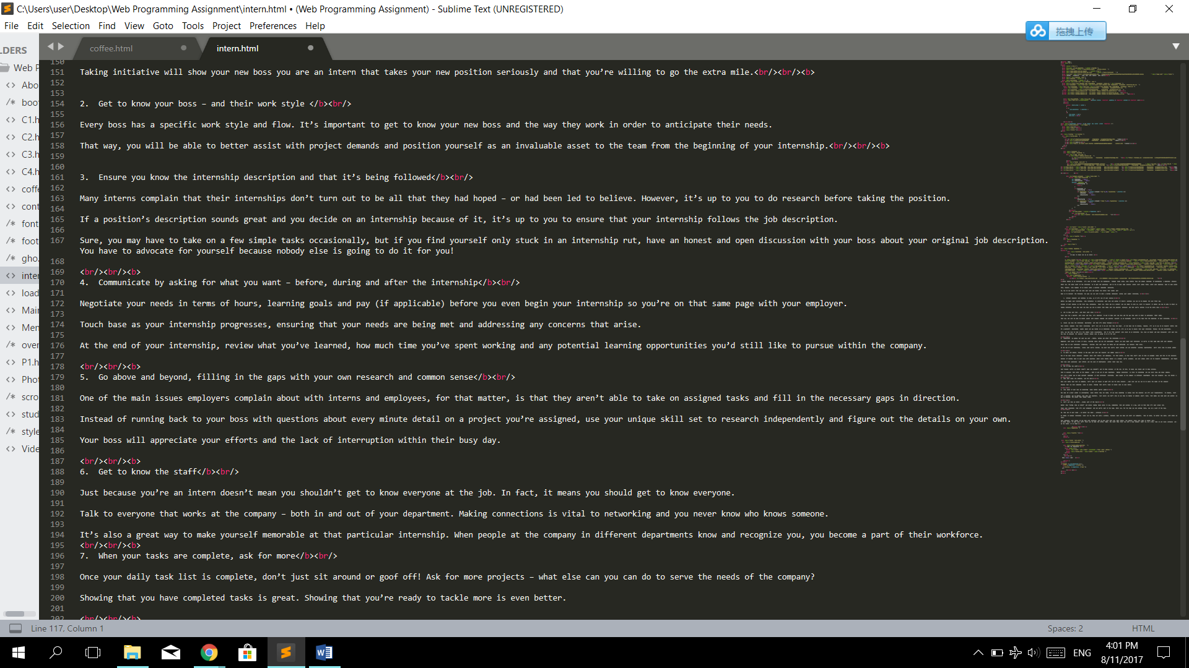

**References**

1. <https://codepen.io/riogrande/pen/gbXxdx?q=overlay+menu+&limit=all&type=type-pens>
2. <https://www.w3schools.com/w3css/w3css_templates.asp>
3. <http://www.lifehack.org/articles/technology/24-useful-tricks-for-the-iphone-and-ipad-most-people-dont-know.html>
4. <http://brobible.com/life/article/10-best-party-lifehacks-might-know/>
5. <http://www.minq.com/lifestyle/8913/19-coffee-hacks-that-every-coffee-drinker-has-to-know-immediately/>
6. <https://colorlib.com/wp/css-layouts/>
7. <https://getbootstrap.com/docs/3.3/css/>
8. [https://www.pinterest.com/search/pins/?q=life%20hack&rs=typed&term_meta[]=life%7Ctyped&term_meta[]=hack%7Ctyped](https://www.pinterest.com/search/pins/?q=life%20hack&rs=typed&term_meta%5b%5d=life%7Ctyped&term_meta%5b%5d=hack%7Ctyped)